LAUR-06-0940 International Utilities Revenue Protection Association News 16(1): 17-18 (April 2006).

New Research on Tamper-Indicting Seals

Roger G. Johnston, Ph.D., CPP
Vulnerability Assessment Team
Los Alamos National Laboratory
MS J565, Los Alamos, NM 87545
505-667-7414 rogerj@lanl.gov
http://pearl1.lanl.gov/seals

Introduction

This article summarizes the research findings of the Vulnerability Assessment Team (VAT) at Los Alamos National Laboratory (LANL). The VAT has extensively studied tamper-indicating seals for the past 15 years. Such seals have an important role to play in reducing revenue loss in the utility industry. Unlike locks, seals are not meant to physically deter unauthorized access, just record that it took place.

Seal Vulnerabilities

The VAT has analyzed hundreds of different seals. This includes government and commercial seals, from low-tech mechanical seals through high-tech electronic seals. The unit cost of these seals varies by a factor of 10,000.

We have demonstrated how all these seals can be defeated quickly and easily using tools, supplies, and methods readily available to almost anyone. While we have access to considerable high technology at LANL, we have not yet seen a seal that requires high-tech attacks. This is true even for seals used in nuclear applications!

(To “defeat” a seal means to attack the seal by removing it, then re-sealing using either the original seal or a counterfeit, without being detected. Merely yanking a seal off a utility meter, lock box, container, or valve, for example, does not defeat it because the fact that the seal is missing or damaged will be noted at the time of inspection.)

We have studied 244 different seals in considerable detail, plus approximately 200 additional seals in lesser detail. The discussion here focuses on the 244 most carefully studied seals, but the results are qualitatively similar for the others. Figure 1 shows the percent of the 244 seals that can be defeated in less than a given amount of time by one person, well practiced in the attack, working alone, and using only low-tech methods.

We declared that a given seal had been defeated when the attack reliably fooled the actual field inspection procedure used for the specific application of interest. With seals for which we had no specific application and/or users, we employed an installation and inspection protocol that was recommended by the seal manufacturer. When that did not exist, we devised a protocol that we judged to be typical for seals of that type.

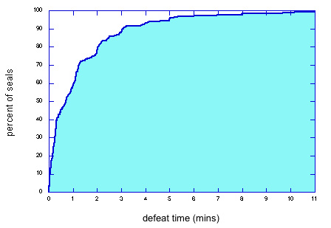

Fig 1 - Percent of seals that can be defeated in less than a given amount of time by 1 person. For some seals,
an assistant would decrease the defeat times plotted here, but for others, an assistant just gets in the way.

How did we know that an attack was successful, i.e., a defeat? For 7% of the 393 different attacks we developed, this was proven via rigorous blind or double blind tests involving the actual seal users and/or inspectors. For another 7% of the attacks, they also could not detect the attacks by examining attacked seals but the testing was more informal. For 22% of the attacks, we demonstrated the attack to the seal users and/or inspectors and they told us the attacks were viable. In 30% of the cases, a briefing on how the attacks work was sufficient to convince the seal users. For 34% of the attacks (including for seals not yet in field use), there was no available seal user or application to test against. We judged those attacks to be successful based solely on our own experience.

Figure 2 demonstrates that expensive high-tech electronic seals are not substantially better than low-cost mechanical seals—at least the way the seals are currently designed and used. Defeat time is plotted vs. seal cost. The correlation between defeat time and cost is very weak (linear correlation coefficient r=0.10 ). Moreover, adding an extra dollar per seal to the unit cost only adds 0.3 seconds to the defeat time on average.

Table 1 summarizes our findings. The average attack time for the fastest attack on each seal is 1.4 minutes, with a median value of only 43 seconds. The cost and marginal cost of the attacks are also quite low. Perhaps the most telling statistic is that we needed an average of 2.3 hours (12 mins median) to devise what ultimately proved to be a successful attack—though it often took much longer to become proficient at the attack. In other words, these attacks are fairly obvious.
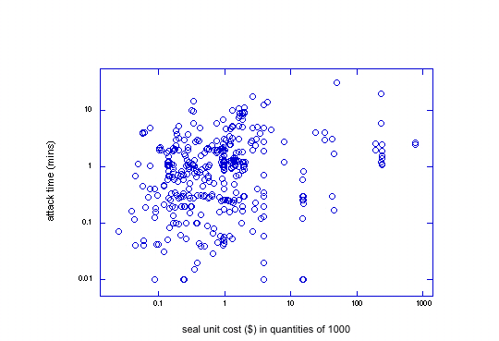

Fig 2 - Log-log plot of defeat time vs. seal cost (in quantities of 1000) for
393 different attacks on 244 seals, 1 to 8 distinct successful attacks per seal.

parameter | mean | median
attack time | 1.4 mins | 43 secs
cost of tools & supplies | $78 | $5
marginal cost of attack | 62¢ | 9¢
time to devise the attack | 2.3 hrs | 12 mins

Table 1 - Summary of the fastest attacks for 244 different seals. The mean is the average value.
The median is the midpoint—half the seals fall below that value, and half lie above it. The marginal cost
of an attack is the cost to attack another seal of the same design by reusing the attack tools and supplies.
Countermeasures

60% of the attacks have simple and inexpensive countermeasures. These may involve minor modifications to the seal, but more often involve changes to the seal installation and inspection procedures. 27% of the attacks have countermeasures that are feasible, but not particularly simple or inexpensive.

In our view, effective tamper detection requires seal inspectors to fully understand the vulnerabilities associated with their application and the specific seals(s) they are using, and then look for the most likely attack scenarios. This requires effective training, multiple samples of attacked seals, and practice.

Better Seals

We also believe that much better seals are possible. Conventional seals have a fundamental design flaw. Once tampering is detected, they must store the “alarm condition” until inspection time. Adversaries, however, can too easily hide or erase the alarm condition, or replace the seal with a fresh counterfeit.

In our view, there is a much better approach: “anti-evidence” seals. With these novel seals, we store information in or on the seal when it is first installed that indicates that tampering has not yet occurred. When tampering is later detected, this “anti-evidence” information is instantly erased. There is thus nothing for an adversary to hide, erase, or counterfeit. The absence of the anti-evidence at inspection time indicates that tampering has occurred.

The VAT has developed nearly two dozen prototype anti-evidence seals, both mechanical and electronic. Some of their advantages include much better security, low cost, full reusability (even if mechanical), and the fact that no tools are needed to install or remove the seal. These anti-evidence seals also allow us to automatically verify that the seal inspector actually checked the seal, rather than just claiming to have done so.

Conclusion

For more information, contact the author or visit the VAT home page at http://pearl1.lanl.gov/seals.

Acknowledgements

The views expressed here are those of the author and should not necessarily be ascribed to LANL or the U.S. Department of Energy. Anthony Garcia, Jon Warner, Adam Pacheco, Ron Martinez, Leon Lopez, and Sonia Trujillo made major contributions to this work.

