LAUR-06-1312

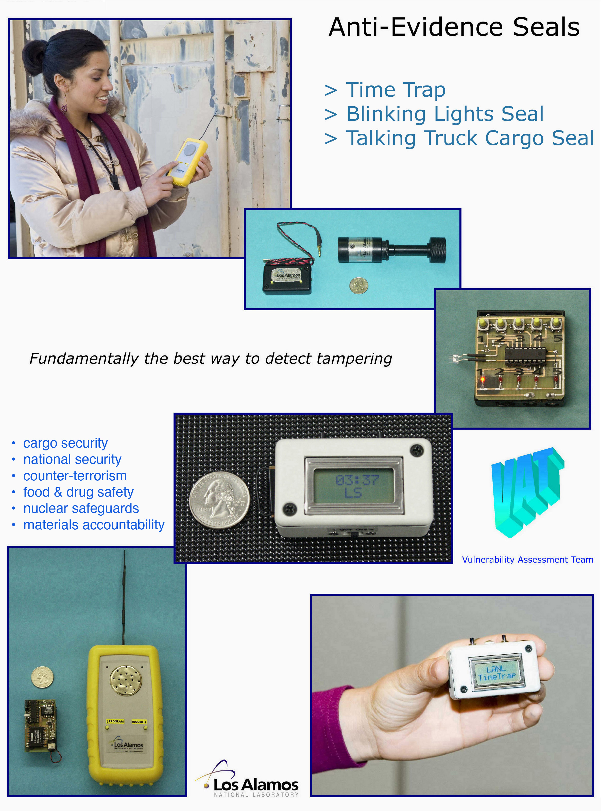

Technology name: Anti-Evidence Seals

* Time Trap
* Blinking Lights Seal
* Talking Truck Cargo Seal
* Tie-Dye Seal

Brief description: These 4 tamper detection devices operate under a completely new principle (“anti-evidence”). This allows them to avoid the fundamental vulnerabilities associated with conventional tamper-indicating seals.

Contact:

Inventor Roger G. Johnston, Ph.D., CPP
Position Team Leader, Vulnerability Assessment Team
Organization Los Alamos National Laboratory
Address MS J565, LANL
City Los Alamos
State NM
Zip Code 87545
Country USA
Phone 505-667-7413
Fax 505-665-4631
Email rogerj@lanl.gov

Co-Developer Jon S. Warner, Ph.D.
Position Technical Staff Member, Vulnerability Assessment Team
Organization Los Alamos National Laboratory
Address MS J565, LANL
City Los Alamos
State NM
Zip Code 87545
Country USA
Phone 505-667-2105
Fax 505-665-4631
Email jwarner@lanl.gov

Prices:
retail cost* retail cost mass produced mass produced
Seal of seal parts of reader parts seal cost† reader cost†
Time Trap | $8 | N/A | $3? | N/A
Blinking Lights Seal | $5 | N/A | $1? | N/A
Talking Truck Cargo Seal | $20 | $45 | $8? | $25?
Tie-Dye Seal | $12 | $6 | $3? | $4?
________________
* Cost in quantities of 1. Differences in prices stated in the DVD video are due to price changes from October
of 2005 to February of 2006.
† Estimate only. We are not very proficient at LANL in accurately determining the cost of commercial mass produced
products. Seals tend to be used in very large quantities.

Patent Positions:

Currently, Los Alamos National Laboratory does not tend to pursue patent protection on physical security devices because they are often used for government applications, which do not generate royalty or licensing income.

Technology Description:

Tamper-indicating seals have been in use for over 7,000 years. Modern seals are meant to detect tampering with the contents of (or unauthorized access into) a variety of different containers. (Throughout this discussion we shall use the term “container” to refer to many different kinds of enclosures such as boxes, cans, drums, bottles, tubes, packages, briefcases, and courier bags; trucks and other vehicles, railcars, transportainers, and ship holds; buildings, rooms, instrumentation racks, utility meters, “lockboxes”, and monitoring equipment.)

Millions of seals are installed every day, just in the United States alone. Some are inexpensive mechanical designs, while others are expensive (but reusable) electronic or electrooptic seals. Figure 1 shows a random sample of various commercial seals.

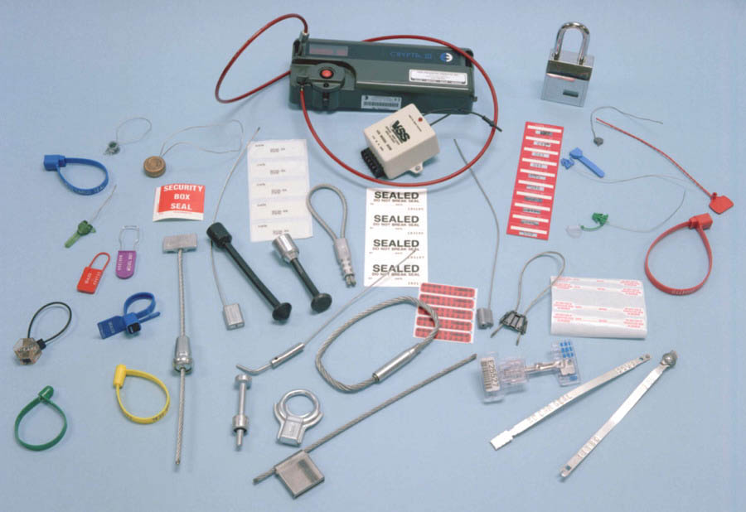
Figure 1 - Examples of various commercial tamper-indicating seals.

Unlike locks, seals are not meant to resist or delay entry, just record that it took place. There are many applications—such as securing food and drugs, or nuclear treaty monitoring—where it is much more practical to know there has been unauthorized access than to try to stop it. (Imagine trying to put a hardened lock on a 79¢ bottle of aspirin!)

Unlike intrusion detectors (“burglar alarms”), seals do not report unauthorized access in real time. For many applications (e.g., cargo security), real-time alarming isn’t usually practical for logistical, economic, or security reasons. Instead, seals must be inspected at some point to determine if tampering has occurred. Depending on the seal, the inspection can be done manually and/or by using an electronic “reader”.

The Vulnerability Assessment Team (http://pearl1.lanl.gov/seals) at Los Alamos National Laboratory and others at different institutions have shown that existing tamper-indicating seals—even those used for nuclear safeguards—can be quickly and easily spoofed using low-tech tools, materials, and techniques available to almost anyone. High-tech electronic or electrooptic seals are not substantially more secure than low-tech mechanical seals. (See the appendix.) Perhaps surprisingly, the use of radio frequency identification devices (RFIDs) and contact memory buttons (CMBs) actually decrease seal security.

We developed our new seals in response to the easy-to-exploit vulnerabilities of existing seals, including high-tech electronic or electrooptic seals. The theory of anti-evidence seals was outlined by the chief inventor (Dr. Johnston) in a paper that appeared in 2005 in the peer-reviewed journal Packaging, Transport, Storage & Security of Radioactive Material. (See appendix.)

The basic idea is that conventional seals have a fundamental design flaw. While it is relatively easy to detect unauthorized access to a container or truck (for example), a conventional seal must store the “alarm condition”, i.e., the fact that intrusion has occurred, until such time as the seal can be inspected. But it is simply too easy for an adversary to erase or hide the alarm condition, or replace the original seal with a fresh counterfeit or replicate seal.

With anti-evidence seals, we store—at the very start when the seal is first installed—information in (or on) the seal that unauthorized access has not yet occurred. As soon as intrusion is detected, this information is instantly erased. At inspection time, the absence of this “anti-evidence” tells us that unauthorized access has taken place.

The anti-evidence must be kept secret, but only for the duration of the cargo shipment or length of time that the seal is monitoring for tampering. New, unpredictable anti-evidence is generated each time an anti-evidence seal is reused.

With a password anti-evidence seal, such as our Blinking Lights Seal, Talking Truck Cargo Seal, or Tie-Dye Seal, the seal inspector must convince the seal that he is the good guy before the seal will release the anti-evidence. This is conveniently handled by the seal reader for the latter two seals. For the Blinking Lights Seal, a 2-digit password (or “combination”) is entered manually.

The Time Trap is an anti-evidence seal that operates quite differently from the other 3 seals. It does not require a password, but instead displays the time-varying anti-evidence in a manner that informs the good guys about tampering, but that does not help the bad guys figure out what the correct anti-evidence should be in the future. The Time Trap relies on two fundamental facts: (1) time only travels in the forward direction, and (2) the bad guys must enter a truck, railcar, or transportainer before the good guys open it at the cargo destination if they are to accomplish their nefarious goals.

Anti-Evidence Seal #1 - Time Trap

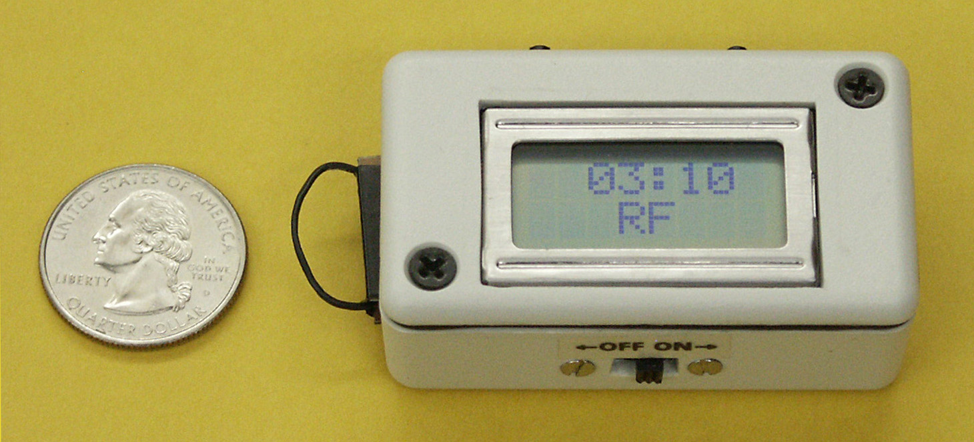
Figure 2 - The Time Trap display after the container is opened. The time that the container was opened (either elapsed or Greenwich Mean Time) is permanently displayed, along with the two letter hash (“RF” in this case) corresponding to that time. The hash is computed from the secret key, K.

The Time Trap, shown in figure 2, uses a Microchip 16F819 microprocessor. The microprocessor is programmed to compute a new hash value each minute that the seal is in use based on the time. (Roughly speaking, a “hash value” is a fixed length number computed from a larger number in a complex and irreversible manner.) While monitoring takes place, the seal is inside the container and shows nothing on its liquid crystal display (LCD).

The anti-evidence used by the Time Trap is a secret key, K, in the range 00001 to 65535. The value of K is used by the hash algorithm. K is randomly chosen by the seal each time it is powered up, based on the exact microsecond when the user presses the start button. (Alternate designs of the Time Trap allow the user to choose K.)

Once the seal detects that the container has been opened (by either the good guys or the bad guys), it immediately erases both the secret key (in a few µsecs) used by the hash algorithm and parts of the hash algorithm itself (in a few msecs). This erasure prevents an intruder from being able to predict future hash values. After erasure, the display permanently shows the time that the container was opened and the (previously computed) hash value associated with that time. The displayed hash value is of no help in determining future hash values, so intruders will not be able to determine what hash value should be on the display when the good guys later open the container. (On
average, 400 different K values yield the same hash value for a given time—even if the adversary fully understands the hash algorithm.)

The seal inspector can conclude that unauthorized access did NOT occur if the time and corresponding hash value is correct. Hash values can be checked using a computer program (see Appendix), or with a hand-held microprocessor circuit. Alternatively, the seal inspector can report the time and hash back to headquarters for checking. A secure communication channel is not necessary, because an adversary cannot reliably tamper with the communication in a way that hides the evidence of tampering.


Rather than literally being a number, the hash value displayed by the Time Trap consists of 2 letters (“RF” in figure 2). Each letter in the two-letter hash is chosen from a set of 13 possible letters. The set of possible letters for English speakers is {AEFGHKLMRSUWX}. These letters were selected because they sound and look distinct from among all 26 letters of the alphabet. Also, we wanted to avoid the letters O and I because they can be confused with the digits zero and one. A different set of 13 letters is used for other languages, e.g., {AEFJMRTUVWXYZ} for German and {GHJKMQRSTWXYZ} for Spanish.

With two-letters, each chosen from 13 possibilities, the odds than an adversary can guess the correct hash value is 1 in 13x13 = O.59%. (He only gets one chance.)

The simplest Time Trap has a light sensor to detect when a light-tight (or nearly light-tight) container has been opened. It also monitors the battery voltage and seal temperature to detect attacks on the seal. When the Time Trap first starts monitoring inside the container, it measures the beginning background light level, battery voltage, and temperature. These baseline levels are used to compute the threshold levels for deciding that tampering has occurred.

At additional cost, the Time Trap in figure 2 can monitor up to 14 additional sensors simultaneously. When multiple sensors are used, they are polled in a random, unpredictable, constantly changing order so that an adversary cannot predict when a given sensor will be read by the seal. Sensors that can be used with the Time Trap include commercial, solid-state Hall Effect magnetic sensors, color sensors (as with the Tie-Dye Seal), tilt detectors and accelerometers (for stationary assets), ultrasonic motion detectors, and passive infrared detectors.

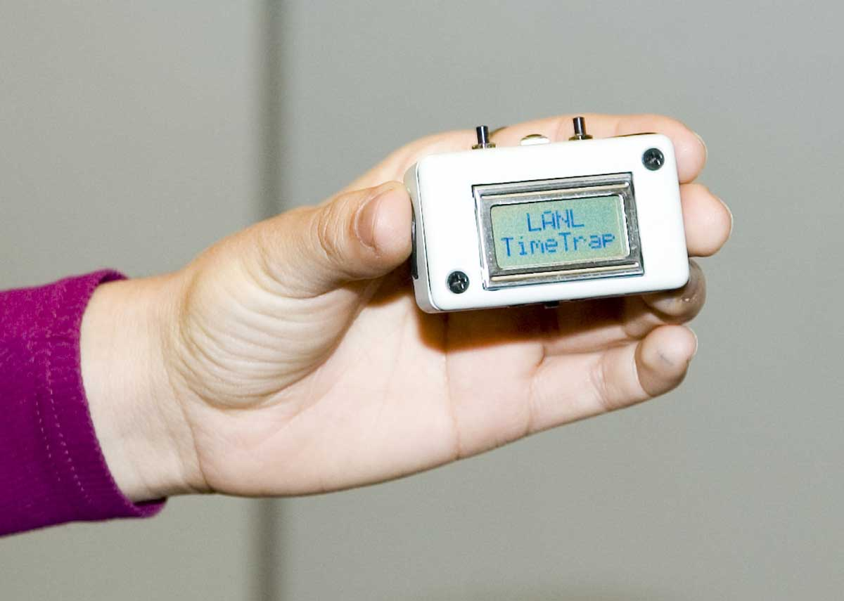

Anti-Evidence Seal #2 - Blinking Lights Seal

Figure 3 shows an even less expensive type of anti-evidence seal, which we call the Blinking Lights Seal. It consists of 5 light emitting diodes (LEDs), 5 push buttons, one or more sensors, and batteries. The 5 LEDs are labeled 1 through 5, as are the 5 push buttons.

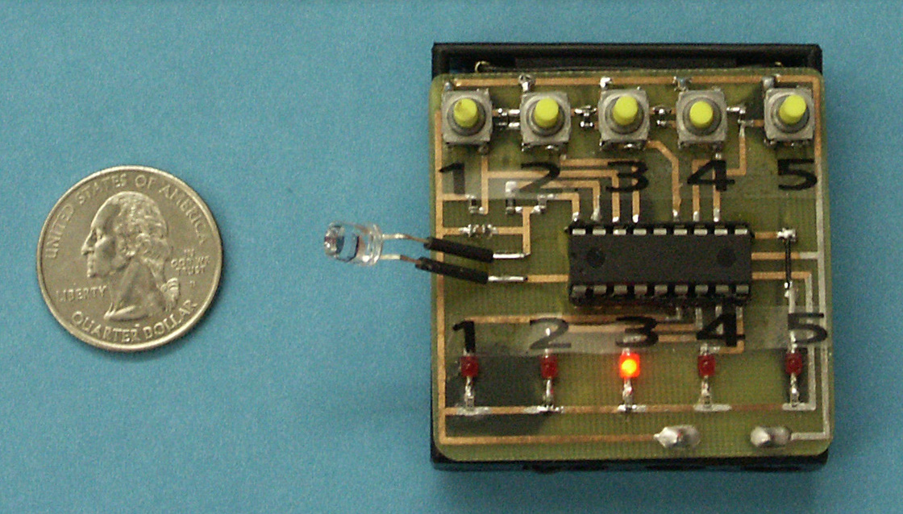
Figure 3 - The Blinking Lights Seal with a light sensor. The seal is shown without its case.

Like the Time Trap, this seal requires no reader, and is typically placed inside the container to be monitored for unauthorized access. It can use the same sensors as the Time Trap.

When the Blinking Lights Seal is first turned on, it chooses two random numbers: a password (or “combination”) and an “anti-evidence” number. Like the Time Trap, these are chosen based on the exact microsecond that the user pushes a start button. Each number has 25 possible values, and is a 2-digit number of the form xy, where x={1,2,3,4,5} and y={1,2,3,4,5}. Prior to inserting the seal into a container, the combination and anti-evidence are displayed by using the LEDs to blink the 4 digits. For example, if the combination was 33 and the anti-evidence was 54 (as in the accompanying DVD video) the seal would blink the sequence 3-3-5-4 continuously until the user is ready to insert the seal into the container to be monitored. Both the combination and the anti-evidence must be recorded by the seal user for use at seal inspection time.

At inspection time, the seal user first opens the container. She then has 1 minute to enter the correct combination into the seal by using the buttons on the seal. (This 1-minute time period can be modified, if desired.) If she fails to enter a combination within 1 minute, the seal erases the stored combination and anti-evidence. It then indefinitely repeats a pattern of blinking LEDs that indicates that the seal has gone “offline”. (A seal inspector that encounters the offline mode immediately upon opening the container knows that unauthorized access has previously occurred.)

If the seal inspector does enter the correct 2-digit combination within 1 minute AND the container has not been previously opened, the seal then flashes the correct 2-digit anti-evidence for a period of 1 minute. After that, the seal goes into offline mode.

If the bad guys enter the wrong combination into the seal—and they only get one chance—the seal instantly erases the correct anti-evidence (in a few µsecs) and flashes two phony digits instead of the correct anti-evidence. The bad guys, however, cannot tell the true anti-evidence from the fake.

The bad guys have only a 1 in 25 (4%) chance of correctly guessing either the combination, or the anti-evidence to program into the seal or a counterfeit seal in order to fool the seal inspector. Reduced odds are possible by adding more LEDs and/or buttons to the seal, or by using a LCD such as on the Time Trap instead of LEDs. Doing this, however, would increase the cost of the seal.

Anti-Evidence Seal #3 - Talking Truck Cargo Seal

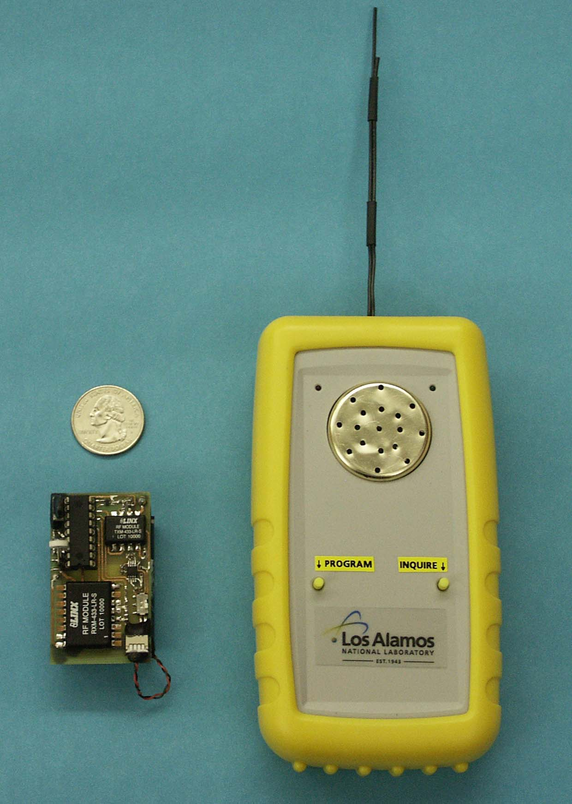
Figure 4 - Talking Truck Cargo Seal. The seal (left) is placed inside the truck (or container) to monitor for unauthorized access, while the handheld unit (right) communicates with the seal from outside using short-range radio frequency signals.

Figure 4 shows the Talking Truck Cargo Seal and its reader. The unit at the right of the figure is the reader, which remains outside the truck (or container) being monitored for unauthorized access. It can communicate with up to 1000 different seals using short-range, 434 MHz radio frequency (rf) signals.

The seal goes inside the truck (or container) to be monitored. It includes a light sensor, but can use a variety of additional or alternative sensors like the Time Trap. When the seal first starts monitoring, it will verbally complain to the seal installer if the background light level inside the container is too high, or if the battery voltage is too low for sustained monitoring.

The seal was designed for a fictitious trucking company. For one version of the seal, the anti-evidence consists of one randomly chosen slogan out of 135 possible slogans used by the company. These slogans are not secret. In fact, it is advantageous if the seal inspectors are quite familiar with all the slogans. What is kept secret is exactly which slogan was chosen for each shipment. A new, random choice of slogan is made (by the reader) each time a seal is reused. An example slogan is, “Safety always comes first!”.

After the container or truck is closed up, the reader in figure 4 chooses a secret, random 4-byte password and one of the slogans. This information is transmitted by rf to the seal inside the truck through the truck or transportainer wall (even if metal). The seal then stores it until unauthorized access is detected.

The reader can store password and slogan information for 1000 different seals. This information can be duplicated or read out to a computer or other readers in a variety of ways so that the secret information can be sent (using encryption or a secure communications channel) to the cargo’s destination where it will be needed for seal inspection.

The version in figure 4 has the reader speak the slogan through a built-in speaker, although an earphone plug is provided for use in noisy environments like loading docks. Other versions of the Talking Truck Cargo Seal have the truck itself do the speaking. This simply requires that a small speaker be added to the seal, or to the inside or outside wall of the truck. We use a digitally recorded human voice, rather than synthesized speech because this makes the slogan easier to understand. The slogan is repeated 3 times to be sure it is heard.

Only if the correct password is sent by the reader to the seal in the correct rf format AND if there was no unauthorized access, will the correct slogan be spoken at inspection time. If the wrong password is sent, the password and anti-evidence are erased by the seal, and a different slogan is spoken so as not to tip off the bad guys that their intrusion was detected. For ease of use, the inspector can check off which slogan was heard from an alphabetized checklist of all possible slogans on a clipboard.

Having a spoken slogan keeps the seal inspection process at a very human level. This is advantageous from a psychological standpoint. Too often, automated high-tech seal readers distract the seal inspectors, or mentally remove them from personal involvement in the details of the shipment. This is not conducive to good security.

With 135 possible slogans, an adversary has a 1 in 135 (0.7%) chance of guessing the correct slogan. Then he must program the original seal or a counterfeit to say the correct slogan when the secret password is presented. He does not get a second chance. If even better odds are desired, up to 4000 possible slogans can be stored in the seal.

Anti-Evidence Seal #4 - Tie-Dye Seal

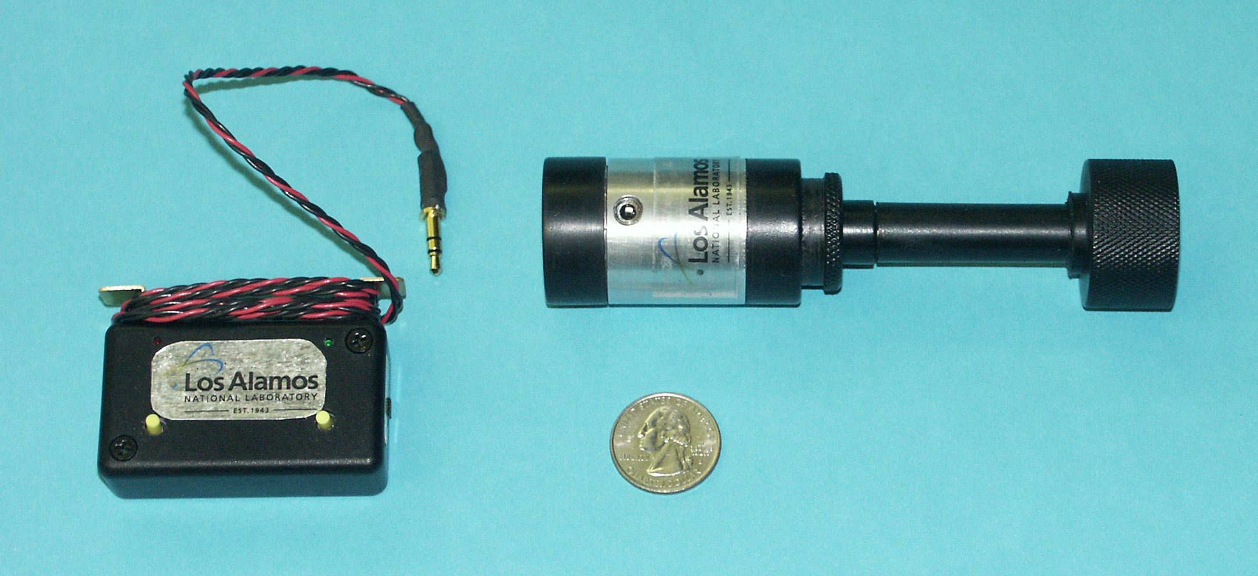
Figure 5 - Tie-Dye Bolt Seal (right) and its reader (left). The two halves of the bolt seal snap together through a hasp.
The seal can be opened by hand without tools simply by pulling the two halves apart.

Color can be a difficult property to accurately counterfeit, thus making it of interest for tamper detection. Recently, small, inexpensive solid-state color sensors with remarkable color resolution have become commercially available. These perform precise color measurements that were previously available only with expensive colorimeters or spectrophotometers. For example, the TAOS TCS230 color sensor outputs RGB color values from an electronics package approximately 5 x 6 x 1.7 mm in size.

Figure 5 shows a Tie-Dye Bolt Seal that exploits this color sensor. The color sensor is placed inside the hollow body of the seal and rigidly mounted. A white LED is used to provide illumination inside the seal. This does not need to run continuously, but can instead be turned on a random, unpredictable times so that a color spectrum can be measured intermittently (thus extending battery life).

A slightly more involved version of the Tie-Dye seal illuminates red, green, and blue LEDs at random times, each with its own random intensity. This makes it even more difficult for an adversary to match the color response.

The inside of the seal is painted with a complex varying color pattern, not unlike the “tie-dye” T-shirts popular in the 1960’s. Because this interior color pattern is so complex, it is difficult for an adversary to counterfeit it in order to try to defeat the seal. Moreover, any opening of the seal, or relative movement of the colored background with respect to the color sensor, is instantly detected as a substantial change in the color spectrum. (This might not be the case if the background was uniformly colored.) Moreover, any object such as a pick tool or drill bit, even if quite small, that passes between the color sensor and the colored background will also cause a change in the color spectrum. There is no one color that the tool could

be painted that would allow it to blend into the background as it moves. In addition, any ambient light that is allowed inside the seal when the seal is opened or cut will also be detected by the color sensor.

The Tie-Dye Bolt Seal is a password anti-evidence seal. The reader shown in figure 5 plugs into a phono plug in the bolt seal. At startup time, the reader chooses the seal password and anti-evidence, then communicates them to the seal. For inspecting the seal, the reader is again plugged into the seal. A red or green LED on the reader then indicates tampering or no tampering, respectively.

The Tie-Dye color sensing concept can be scaled up to even room-size vaults (though brighter illumination is required). A person sneaking into the vault would need to change color in a very complex, spatially varying way as he moved with respect to the background tie-dye wall pattern. Unlike more expensive video monitoring, there is no need for image processing, high bandwidths, nor are any sensitive images produced of the secret contents of the vault.



Comparisons of anti-evidence seals to other technologies and products:

There are over 5000 different government and commercial tamper-indicating seals. Many are virtually indistinguishable from each other. Most are based on the same dozen or so design concepts. Some major seal manufacturers include Oneseal, EJ Brooks, Tyden Brammall, Canada Mayer, Dickey Manufacturing, Stoffel, Uline, Mega Fortis, Relcor, American Casting & Manufacturing, 3M, NIC Products, and Unisto.

The major categories for tamper-indicating seals include wire loops, metal ribbons, plastic straps, pressure-sensitive adhesive labels, bolts, cables, “padlock” seals, passive fiber optic seals, active fiber optic (electrooptic) seals, and electronic seals.

There currently are no tampering-indicating seals, commercial or government, anything like the Time Trap, which uses an anti-evidence approach along with a complex hash of the time. The anti-evidence password approach used by the Talking Truck Cargo Seal, Blinking Lights Seal, and Tie-Dye Seal is also unique. The Tie-Dye seal is additionally novel in that it is the only existing seal (and apparently the only security device of any kind) that uses (non-video) color sensing.

Table 1 below is a general comparison of existing mechanical seals, existing electronic seals, and our 4 new anti-evidence seals.

Advantages of anti-evidence seals over existing technologies and products:

The most important advantage of our new seals is their greatly enhanced security. The alarm condition cannot be hidden or erased by an adversary because there is no alarm condition. It is the absence of the anti-evidence that signals tampering. Moreover, unlike conventional seals, replacing the seal with a counterfeit or replicate accomplishes nothing for the adversary unless he knows the anti-evidence, which is erased in microseconds when unauthorized access or tampering with the seal is detected.

Table 1 - Seal Comparisions

conventional conventional Talking
mechanical electronic Truck
Feature seals seals Time Blinking Cargo Tie-Dye
Trap Lights Seal Seal Seal
Cost | 4¢-$20 | $25-$2000 | $3? | $1? | $8? | $3?
Security | low | low | high | medium to high | high | medium to high
Counterfeiting the hardware  defeats the seal? | yes | yes | no | no | no | no
Batteries protected from tampering by intrusion sensor(s)? | N/A | no | yes | yes | yes | not currently
Makes use of new inexpensive, but advanced solid-state sensors? | no | no | yes | yes | yes | yes
Surface or volumetric monitoring, not just portal monitoring? | no | no | yes | yes | yes | yes*
Reader required? | sometimes | usually | no | no | yes | yes
Tools needed to install the seal? | sometimes | not usually | no | no | no | no
Tools needed to remove the seal? | often | not usually | no | no | no | no
Seal works inside the container, thus making it covert and better protected from deliberate or inadvertent damage? | no | no | yes | yes | yes | not currently
Seal must be inspected before  the container can be opened? | yes | yes | no | no | yes | yes
Seal must be removed before  the container can be opened? | yes | usually | no | no | no | yes
Seal can be checked  multiple times for tampering  without opening the container? | usually | usually | no | no | yes | yes
Anti-gundecking capabilities? | no | no | yes | yes | yes | not currently
___________
* Volumetric within the tie-dye bolt seal.

Other advantages of our anti-evidence seals over conventional seals include:

• Relatively low cost

• Small size and weight (important for shipping applications)

• No tools are needed to install or remove the seal.

• Two of the seals (Time Trap, Blinking Lights Seal) do not require a reader.

• Volumes or surfaces are monitored, not just portals (e.g., doors and lids) as with most conventional seals.

• Three of our 4 seals are designed to be placed inside the container being monitored for tampering. (The Tie-Dye seal could be modified for such internal use.) This means that:
+ The seal can be used as a “trap” (covert seal) because there
is no external evidence that tamper detection is underway.
+ The seal is protected from deliberate or inadvertent damage.
+ The seal does not have to be removed to open the container. (This
is useful in an emergency.)
+ For the Talking Truck Cargo Seal, it is possible to check the seal for
unauthorized access multiple times from outside, without opening
the container.

• Anti-gundecking: We can automatically verify that the seal inspector actually inspected the seal (rather than just claiming that he did) by not telling him what the anti-evidence is in advance. Instead, he must report it. But obtaining the anti-evidence is equivalent to checking for tampering. Anti-gundecking is a very important advantage, especially for cargo security and utility meter inspection, because the job of seal inspector is typically a tedious and thankless task, often relegated to under-appreciated and unmotivated personnel. (“Gundecking” is an 18th century naval term for shirking one’s duties.)
Applications:

The principal applications for these new tamper-indicating seals include cargo security (trucks, railcars, transportainers, etc.), and such homeland security applications as port security, customs, nuclear safeguards, counter-intelligence, and protecting food and drugs.

Other applications include airline security, records integrity, treaty verification, drug accountability, warehouse security, hazardous materials accountability, waste management, countering utility theft, safes & security vaults, banking & courier bags, business loss prevention, corporate security, guaranteeing medical sterilization and instrument calibration, securing drug testing specimens and results, securing election ballots & voting machines, law enforcement and forensics chain-of-custody, hotel mini-bars, and weapons/explosives/ammunition accountability.

Summary:

In the history of tamper detection, major advances have been made with the invention of the stamp seal (6000 BC?), the cylinder seal (3200 BC), the lead seal (4th century AD), railcar seals (1880s), electronic seals (1980s), and electrooptic seals (1990s). We believe that the anti-evidence approach to tamper detection has the potential to be nearly as significant an innovation.

Unfortunately, most (all?) current government and commercial tamper-indicating seals (even high-tech ones) can be quickly and easily spoofed using low-tech tools, materials, and techniques available to almost anyone. This is a serious matter because seals play an important role in homeland security—especially for port, cargo, and nuclear security.

Our seals approach tamper detection from a completely new angle, based on our understanding of the vulnerabilities associated with conventional seals. We have actually devised over 20 new seal designs, many based at least partially on the anti-evidence concept. Because of budget limitations, however, only the 4 seals described here have been developed beyond the proof-of principle stage. Indeed, our work on anti-evidence seals was done on a shoestring budget—at least by national laboratory standards—because (remarkably) we could find very little interest in better tamper-indicating seals in Washington, D.C.

There was actually more interest in serious seal R&D prior to September 11, 2001, despite the current threat of terrorism and the widespread recognition that port and cargo security are inadequate! In recent years, the Department of Homeland Security has focused its seal efforts primarily on non-substantive demonstrations of existing commercial seals for use on trucks and transportainers, without even a rudimentary consideration of their vulnerabilities. And the U.S. Department of Energy (DOE) and the National Nuclear Security Administration (NNSA) have not pursued any significant new seal development since 1993, despite the importance of seals for nuclear safeguards and nonproliferation. Few (if any) private companies are developing new, imaginative seal designs either.

Appendix

* How to Use the Anti-Evidence Seals

* About the Inventor & Co-Developer; Acknowledgments

* Partial Bibliography

* RG Johnston, “New Research on Tamper-Indicating Seals”, Los Alamos National Laboratory Report LAUR-06-0940, January, 2006.

* RG Johnston, “The ‘Anti-Evidence’ Approach to Tamper Detection”, Packaging, Transport, Storage & Security of Radioactive Material 16, 135-143 (2005).

How to Use the Anti-Evidence Seals

A. Time Trap

To install the seal:
1. Power up the seal using the sliding on-off switch.
2. When ready to begin, press the (left) start button.
3. The seal displays the random key (K value), chosen based on the exact microsecond you depressed the start button. Jot this number down.
4. When ready to start monitoring for tampering, press the (right) begin button. The countdown begins, during which time you need to place the seal inside the container and close the container.

To inspect the seal:
1. Open the container normally.
2. Is the time on display correct to within a minute or so? If not, tampering has occurred.
3. Is the hash value correct for the displayed time? If not, tampering has occurred. To check the hash value, enter the value of K and the displayed time into our hash program that runs on Mac or PC notebook computers, or use a handheld microprocessor unit, or report the time, hash, and K value to headquarters so they can determine if tampering occurred.

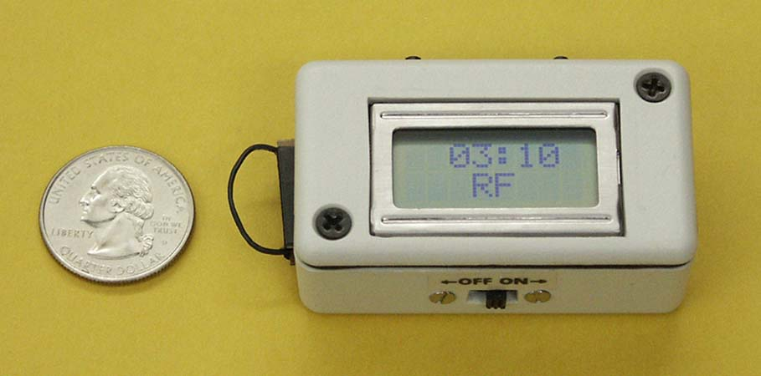
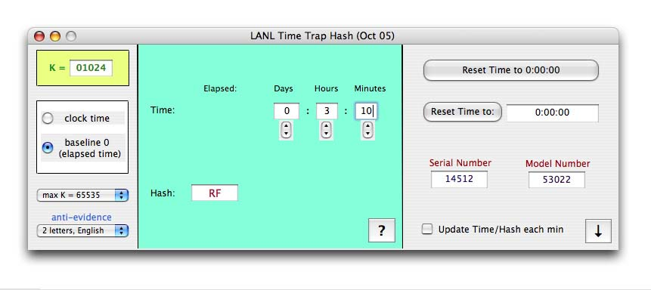

To reuse the seal:
1. Turn the seal off, then on again.
2. A new K value will be generated.

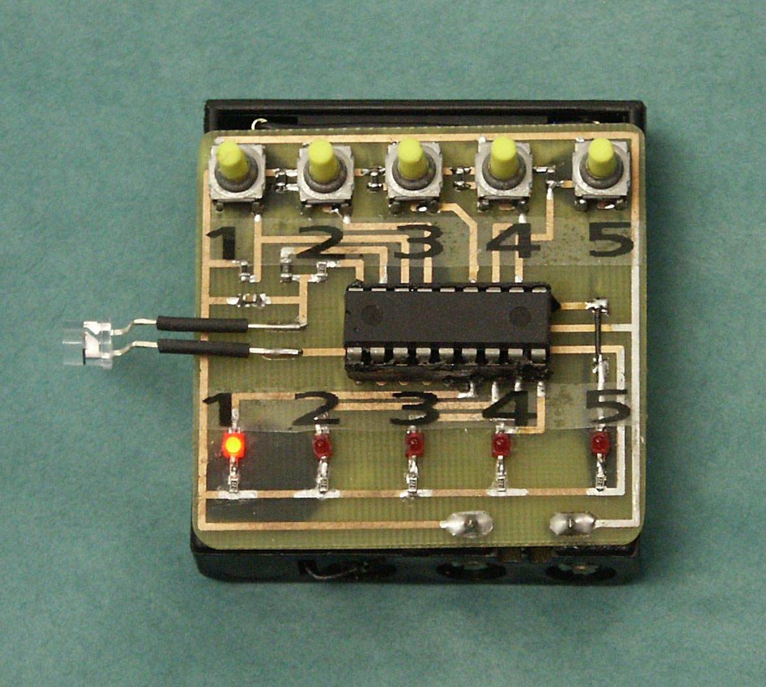
B. Blinking Lights Seal

To install the seal:
1. Power up the seal.
2. When ready to begin, press any button to start.
3. Jot down the 4 random digits that the seal is repeatedly flashing. The first two digits are the password (“combination”). The next two digits are the anti-evidence.
4. Press any button 1-5 to begin. The countdown time increases with increasing button number. You can tell from the pattern of flashing LEDs approximately how much time is left.
5. Place the seal inside the container and close the container before the countdown time expires.

To inspect the seal:
1. Open the container normally.
2. Is the sealing flashing the LEDs? If so, tampering has occurred.
3. If not, you have one minute to enter the 2-digit combination. The seal will then flash two digits. If it is the correct anti-evidence, no tampering has occurred. If it is the wrong 2-digits, tampering has occurred.

To reuse the seal:
1. Turn the seal off, then on again.
2. A new, unpredictable, 2-digit combination will be chosen by the seal, along with a new, unpredictable, 2-digit anti-evidence value.

C. Talking Truck Cargo Seal

To install the seal:
1. Turn on the seal and turn on the reader using their respective on-off switches.
2. Place the seal inside the container and close the container.
3. Press the (left) program button on the reader. The reader will say the chosen slogan 3 times, and then the seal will start monitoring. Jot down the slogan or make a mental note of it.
4. Power off the reader.

To inspect the seal:
1. You do not need to open the container.
2. Turn on the power to the reader.
3. Press the (right) inquire button. The reader automatically figures out which of 1000 possible seals it is talking to.
4. If you hear the correct slogan, there has been no tampering. If you hear no slogan or the wrong slogan, tampering has occurred.
5. You can make up to 3 tamper inquiries without opening the container. (This number is adjustable.) After that, the password and slogan are erased by the seal.

To reuse the seal:
1. Reprogram it using the reader’s (left) program button. A new password and random slogan will be chosen. (It is not necessary to open the container.)

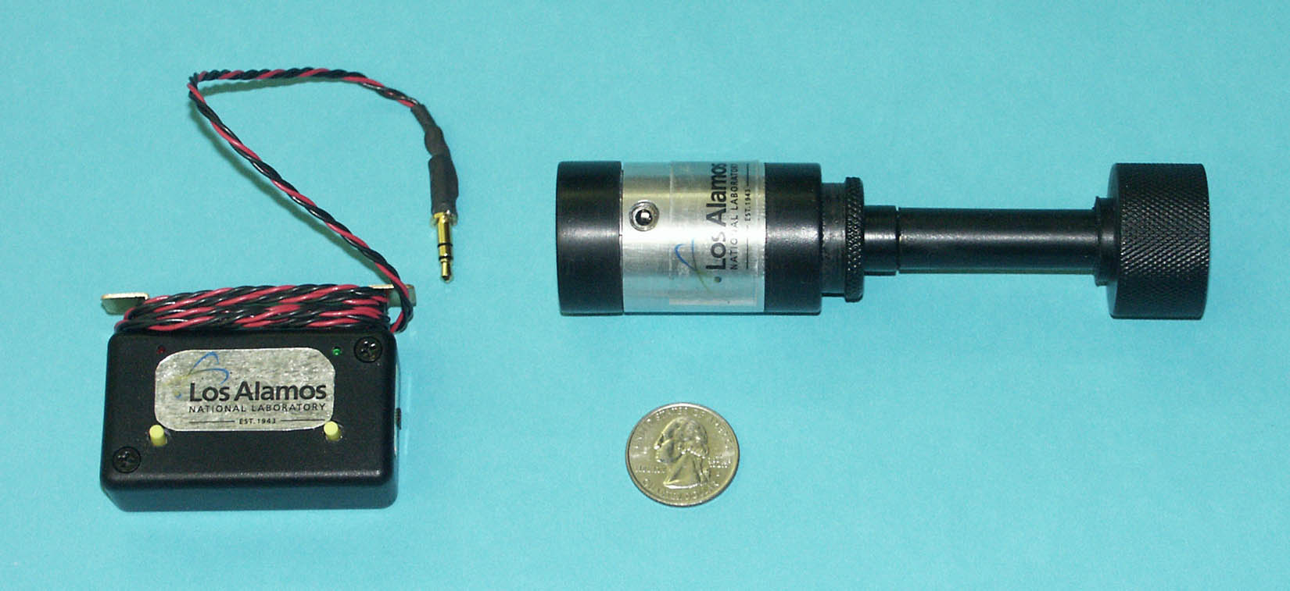
D. Tie-Dye Seal

To install the seal:
1. Power up the seal and the reader.
2. Snap the two halves of the bolt seal together through a hasp on the truck or container door.
3. Plug the reader’s cable into the seal.
4. Press the (left) program button.
5. Disconnect and power down the reader.

To inspect the seal:
1. Power up the reader.
2. Plug the reader’s cable into the seal.
3. Press the (right) inquiry button on the reader. If the red LED comes on, there has been tampering. If the green LED comes on, there hasn’t been tampering.

Partial Bibliography

RG Johnston, DD Martinez, and ARE Garcia, "Were Ancient Seals Secure?", Antiquity 75, 299 (2001).

RG Johnston, “Assessing the Vulnerability of Tamper-Indicting Seals”, Invited Review Article for Port Technology International 25, 155 (2005).

RG Johnston and JS Warner, “Don’t Swallow the Snake Oil: Understanding the Limitations and Vulnerabilities of High-Technology”, Security Management 49(9), 112-121 (Sept 2005).

RG Johnston, JS Warner, ARE Garcia, et al., "Nuclear Safeguards and Security: We Can Do Better", Proceedings of the 10th International Conference on Environmental Remediation and Radioactive Waste Management, September 4-8, 2005, Glasgow, Scotland.

RG Johnston, ARE Garcia, AN Pacheco, SJ Trujillo, RK Martinez, DD Martinez, & LN Lopez, “Improving Tamper Detection for Hazardous Waste Security”, Proceedings of Waste Management ’03, Tucson, AZ, Feb 24-27, 2003, www.osti.gov/servlets/purl/8276090lRad9/native/

RG Johnston, ARE Garcia, and AN Pacheco, “The ‘Town Crier’ Approach to Monitoring”, International Journal of Radioactive Material Transport 13, 117 (2002).

RG Johnston, ARE Garcia, and AN Pacheco, "Efficacy of Tamper-Indicating Devices",
Journal of Homeland Security, April 16, 2002,
http://www.homelandsecurity.org/journal/Articles/displayarticle.asp?article=50

RG Johnston, "Tamper-Indicating Seals for Nuclear Disarmament and Hazardous Waste Management", Science and Global Security 9, 93 (2001).

RG Johnston, "Tamper Detection for Safeguards and Treaty Monitoring: Fantasies, Realities, and Potentials", Nonproliferation Review 8, 102 (Spring 2001),
http://www.princeton.edu/~globsec/publications/pdf/9_2johnston.pdf

RG Johnston and ARE Garcia, "An Annotated Taxonomy of Tag and Seal Vulnerabilities", Journal of Nuclear Materials Management 229, 23 (2000).

RG Johnston, "Tamper Detection Requires Dedication", Metering International, Issue 3, Fall 1999, http://www.metering.com/archive/993/28_1.htm

RG Johnston, J Albrecht, & M Hayward (1999), “Seals” in Guidelines for Cargo Security & Loss Control, L Tyska, Editor (National Cargo Security Council, Washington, D.C.), Chap 4 (29-38).

RG Johnston, et al. (1999), “DoD Training Course for Effective Seal Use” (Naval Facilities Engineering Services Center, Port Hueneme, CA), http://locks.nfesc.navy.mil/lockweb/Security_seals/security%20seals/sp2086.pdf

RG Johnston, "The Real Deal on Seals", Security Management 41, 93 (1997).

RG Johnston, "Effective Vulnerability Assessment of Tamper-Indicating Seals", Journal of Testing and Evaluation 25, 451 (1997).

RG Johnston and ARE Garcia, "Simple, Low-Cost Ways to Dramatically Improve the Security of Tags and Seals", Proceedings of the IAEA Symposium on International Safeguards, Vienna, Austria, October 13-17, 1997.

About the Inventor:
Roger G. Johnston, Ph.D., CPP, has been head of the Vulnerability Assessment Team (VAT) at Los Alamos National Laboratory (LANL) since 1992. The VAT has provided consulting, vulnerability assessments, and security solutions for over 30 U.S. government agencies and private companies, as well as Euratom and the International Atomic Energy Agency (IAEA). Johnston graduated from Carleton College (1977), and received M.S. & Ph.D. degrees in physics from the University of Colorado (1983). He has authored over 90 technical papers and 45 invited talks, holds 10 U.S. patents, and serves as Editor of the Journal of Physical Security. Dr. Johnston has won numerous awards, including the 2004 LANL Fellows Prize for Outstanding Research.

About the Co-Developer:
Jon S. Warner, Ph.D., is a technical staff member with the Vulnerability Assessment Team at Los Alamos National Laboratory. He received B.S. degrees in physics and in business management from Southern Oregon University (1994), and M.S. and Ph.D. degrees in physics from Portland State University (1998 & 2002). His research interests include security devices, vulnerability assessments, electronics, and microprocessor applications.

Acknowledgments:
Leon Lopez, Ron Martinez, Anthony Garcia, Adam Pacheco, and Sonia Trujillo helped clarify our thinking on anti-evidence seals, and assisted in packaging and assembling the seals.
LAUR-06-0940 To appear in the International Utilities Revenue Protection Association (IURPA) News

New Research on Tamper-Indicating Seals

Roger G. Johnston, Ph.D., CPP
Vulnerability Assessment Team
Los Alamos National Laboratory
MS J565, Los Alamos, NM 87545
505-667-7414 rogerj@lanl.gov
http://pearl1.lanl.gov/seals

Introduction

This article summarizes the research findings of the Vulnerability Assessment Team (VAT) at Los Alamos National Laboratory (LANL). The VAT has extensively studied tamper-indicating seals for the past 15 years. Such seals have an important role to play in reducing revenue loss in the utility industry. Unlike locks, seals are not meant to physically deter unauthorized access, just record that it took place.

Seal Vulnerabilities

The VAT has analyzed hundreds of different seals. This includes government and commercial seals, from low-tech mechanical seals through high-tech electronic seals. The unit cost of these seals varies by a factor of 10,000.

We have demonstrated how all these seals can be defeated quickly and easily using tools, supplies, and methods readily available to almost anyone. While we have access to considerable high technology at LANL, we have not yet seen a seal that requires high-tech attacks. This is true even for seals used in nuclear applications!

(To “defeat” a seal means to attack the seal by removing it, then re-sealing using either the original seal or a counterfeit, without being detected. Merely yanking a seal off a utility meter, lock box, container, or valve, for example, does not defeat it because the fact that the seal is missing or damaged will be noted at the time of inspection.)

We have studied 244 different seals in considerable detail, plus approximately 200 additional seals in lesser detail. The discussion here focuses on the 244 most carefully studied seals, but the results are qualitatively similar for the others. Figure 1 shows the percent of the 244 seals that can be defeated in less than a given amount of time by one person, well practiced in the attack, working alone, and using only low-tech methods.

We declared that a given seal had been defeated when the attack reliably fooled the actual field inspection procedure used for the specific application of interest. With seals for which we had no specific application and/or users, we employed an installation and inspection protocol that was recommended by the seal manufacturer. When that did not exist, we devised a protocol that we judged to be typical for seals of that type.

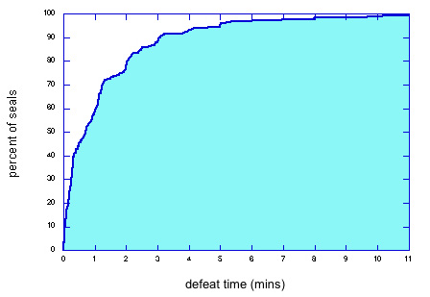

Fig 1 - Percent of seals that can be defeated in less than a given amount of time by 1 person. For some seals,
an assistant would decrease the defeat times plotted here, but for others, an assistant just gets in the way.

How did we know that an attack was successful, i.e., a defeat? For 7% of the 393 different attacks we developed, this was proven via rigorous blind or double blind tests involving the actual seal users and/or inspectors. For another 7% of the attacks, they also could not detect the attacks by examining attacked seals but the testing was more informal. For 22% of the attacks, we demonstrated the attack to the seal users and/or inspectors and they told us the attacks were viable. In 30% of the cases, a briefing on how the attacks work was sufficient to convince the seal users. For 34% of the attacks (including for seals not yet in field use), there was no available seal user or application to test against. We judged those attacks to be successful based solely on our own experience.

Figure 2 demonstrates that expensive high-tech electronic seals are not substantially better than low-cost mechanical seals—at least the way the seals are currently designed and used. Defeat time is plotted vs. seal cost. The correlation between defeat time and cost is very weak (linear correlation coefficient r=0.10 ). Moreover, adding an extra dollar per seal to the unit cost only adds 0.3 seconds to the defeat time on average.

Table 1 summarizes our findings. The average attack time for the fastest attack on each seal is 1.4 minutes, with a median value of only 43 seconds. The cost and marginal cost of the attacks are also quite low. Perhaps the most telling statistic is that we needed an average of 2.3 hours (12 mins median) to devise what ultimately proved to be a successful attack—though it often took much longer to become proficient at the attack. In other words, these attacks are fairly obvious.

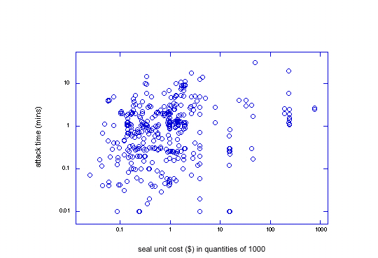

Fig 2 - Log-log plot of defeat time vs. seal cost (in quantities of 1000) for
393 different attacks on 244 seals, 1 to 8 distinct successful attacks per seal.

parameter | mean | median
attack time | 1.4 mins | 43 secs
cost of tools & supplies | $78 | $5
marginal cost of attack | 62¢ | 9¢
time to devise the attack | 2.3 hrs | 12 mins

Table 1 - Summary of the fastest attacks for 244 different seals. The mean is the average value.
The median is the midpoint—half the seals fall below that value, and half lie above it. The marginal cost
of an attack is the cost to attack another seal of the same design by reusing the attack tools and supplies.

Countermeasures

60% of the attacks have simple and inexpensive countermeasures. These may involve minor modifications to the seal, but more often involve changes to the seal installation and inspection procedures. 27% of the attacks have countermeasures that are feasible, but not particularly simple or inexpensive.

In our view, effective tamper detection requires seal inspectors to fully understand the vulnerabilities associated with their application and the specific seals(s) they are using, and then look for the most likely attack scenarios. This requires effective training, multiple samples of attacked seals, and practice.

Better Seals

We also believe that much better seals are possible. Conventional seals have a fundamental design flaw. Once tampering is detected, they must store the “alarm condition” until inspection time. Adversaries, however, can too easily hide or erase the alarm condition, or replace the seal with a fresh counterfeit.

In our view, there is a much better approach: “anti-evidence” seals. With these novel seals, we store information in or on the seal when it is first installed that indicates that tampering has not yet occurred. When tampering is later detected, this “anti-evidence” information is instantly erased. There is thus nothing for an adversary to hide, erase, or counterfeit. The absence of the anti-evidence at inspection time indicates that tampering has occurred.

The VAT has developed nearly two dozen prototype anti-evidence seals, both mechanical and electronic. Some of their advantages include much better security, low cost, full reusability (even if mechanical), and the fact that no tools are needed to install or remove the seal. These anti-evidence seals also allow us to automatically verify that the seal inspector actually checked the seal, rather than just claiming to have done so.

Conclusion

For more information, contact the author or visit the VAT home page at http://pearl1.lanl.gov/seals.

Acknowledgements

The views expressed here are those of the author and should not necessarily be ascribed to LANL or the U.S. Department of Energy. Anthony Garcia, Jon Warner, Adam Pacheco, Ron Martinez, Leon Lopez, and Sonia Trujillo made major contributions to this work.

LAUR-05-0357

Packaging, Transport, Storage & Security of Radioactive Material 16, 135-143 (2005).

THE ‘ANTI-EVIDENCE’ APPROACH TO TAMPER DETECTION

Roger G. Johnston, Ph.D., CPP

Vulnerability Assessment Team
Los Alamos National Laboratory
MS J565, Los Alamos, NM 87545 USA
phone: 505-667-7414, fax: 505-665-4631, email: rogerj@lanl.gov

ABSTRACT

Tamper-indicating seals are widely used for the transport, packaging, and storage of nuclear material. Most existing seals operate under the same basic principle: once the seal is opened, information that the seal has indeed been unsealed is stored in or on the seal until such time as the seal can be inspected. This stored evidence of tampering, however, is often easy to hide or erase. A better approach, discussed theoretically in this paper, is to store information when the seal is first installed that tampering has NOT been detected; this anti-evidence is then erased once the seal is opened. Such anti-evidence seals may provide better security. They also have a number of potentially useful attributes, including an intrinsic check on whether the seal was actually inspected for evidence of tampering (“anti-gundecking”).
INTRODUCTION

Tamper-indicating seals are widely used in the transport, packaging, and storage of nuclear material, and have an important role to play in both domestic and international nuclear safeguards.⁽¹⁻⁵⁾ Seals are meant to detect unauthorized access to containers, packages, instrumentation, records, rooms, and transport vehicles. Unlike locks, seals do not resist entry; they instead record that it took place. Unlike (real-time) intrusion detectors, seals do not report unauthorized access immediately. They must be inspected to determine that unauthorized entry has occurred. This has both advantages and disadvantages, depending on the application of interest.

Existing seals have a large number of easy-to-exploit vulnerabilities.^{(1-3, 6-9)} For example, the Vulnerability Assessment Team (VAT) at Los Alamos National Laboratory⁽¹⁰⁾ has demonstrated how 213 different types of tamper-indicating seals can be quickly defeated using only low-cost, low-tech methods, tools, and supplies available to almost anyone.⁽⁷⁾ These seals include mechanical, electronic, and electrooptic seals, both government and commercial. At least 35 of the 213 seals are currently in use somewhere in the world for nuclear applications, or else are under serious consideration. (An additional 140 seals have been studied by the VAT in much less detail than the original 213 seals, but also appear to be easy to defeat.)

Table 1 summarizes the results for the 213 seals that were studied in detail. To “defeat” a seal means to successfully attack it. This involves opening the seal, then resealing (using either the same seal or a counterfeit) without being detected. Merely cutting or yanking a seal off a container, for example, is not defeating the seal because the fact that the seal is missing or damaged will be noted at the time of inspection.

Note in table 1 the speed and low cost of the attacks. As shown in the table, the time required to devise a successful attack is also minimal, although it may take considerably longer to become proficient at a given attack. Another important finding was that high-tech seals are often easier to defeat than the low-tech seals.⁽⁷⁾

Many of the seal vulnerabilities the VAT has demonstrated can be at least partially mitigated through relatively minor changes to the seal design and/or the use protocols.⁽⁷⁾ It is particularly important to provide seal installers and inspectors with specific, hands-on training, which includes information about the most likely attack scenarios and examples of attacked seals.^{(1,7,10)} Even though countermeasures are available, however, it is clear that better tamper-indicating seals are needed.

This paper concerns a fundamentally new approach to tamper detection—the “anti-evidence” seal. The goal is more effective tamper detection. The idea of anti-evidence seals has been briefly presented elsewhere.^{(11,12)} This paper presents the concept in more detail, including its theoretical advantages, and discusses five different variants of anti-evidence seals:
(1) complexity seals
(2) password seals
(3) challenge-response seals
(4) time traps
(5) saturated response traps

Of these 5 types of anti-evidence seals, only complexity seals currently exist, and they are few in number and based on very limited designs.

The present paper is primarily concerned with the theoretical aspects of anti-evidence seals. An unpublished report⁽¹³⁾ discusses specific seal implementations of the theoretical concepts presented here. The anti-evidence approach also has potential advantages for real time intrusion monitoring, especially for cargo security. Such a real-time, anti-evidence approach is called “Town Crier Monitoring” and has been discussed in previous papers.^{(11,12)}

Some anti-evidence seals can potentially be used as type 1 or type 2 “traps”, i.e., covert seals. The seal resides inside the container, and there is no obvious evidence or hardware on the outside of the container indicating that tamper detection has been implemented. In a type 1 trap, an adversary is unaware of the tamper detection until opening the container (by which time, it is hopefully too late to hide the fact that unauthorized access has occurred). With a type 2 trap, the adversary is unaware even after opening the container. Type 3 traps, reserved for future micro- and nano-technology, are traps where an adversary may be aware that tamper detection is being undertaken, but lacks the time and/or resources to find and defeat the seal because of its small size and uncertain location.

Traps have a significant advantage beyond secrecy—which is usually not a reliable long-term security strategy anyway.⁽¹⁴⁾ Being located inside the container or transport vehicle, they are less subject to accidental or deliberate damage. Particularly for treaty monitoring, “we’re sorry that our forklift crashed into your seal” is a tempting excuse if the inspected nation wishes to hide occasional cheating or a botched attack on a seal.

THE ANTI-EVIDENCE CONCEPT

Most existing tamper-indicating seals operate under the same basic principle. Once the seal is opened, information that the seal has indeed been unsealed is stored in or on the seal until such time as the seal can be inspected. With inexpensive mechanical seals, this “alarm” condition is typically indicated by destruction, damage, or (supposedly) irreversible modification to the seal body. With electronic or electrooptic seals, the alarm condition is usually stored electronically or magnetically within the seal, or shown on an electronic display.

In our experience at Los Alamos, the fundamental problem with conventional seals is that an adversary can usually erase the “alarm” condition with little difficulty. With mechanical seals, this may mean repairing or cosmetically hiding the destruction, damage, or modification that occurred while opening the seal. With electronic seals (“e-seals”), the adversary may attack or erase a memory location, or tamper with the electronic display or other communications from the seal. There are over 100 other general kinds of attacks as well (including counterfeiting a brand new seal), with many possible variations within each category.⁽⁸⁾ Few attacks, however, are as easy to implement, nor as likely to go undetected by the seal user as hiding or erasing the alarm condition.

The best way to permanently and irreversibly record the fact that tampering has occurred is to use an “anti-evidence” approach. Rather than storing information that tampering has occurred (as in a conventional seal), we instead store information when the seal is first installed that indicates that tampering has NOT yet occurred. This information (the “anti-evidence”) is then erased the instant that tampering is detected. When the seal is eventually inspected, the seal inspector will check the anti-evidence. If it is missing or incorrect, she should conclude that tampering has occurred.

Anti-evidence seals can have one or more of the following desirable attributes:
• Greater security.
• Low to moderate cost.
• Simplicity and ease of use.
• The seal is fully reusable—even if mechanical.
• No tools are needed to install or remove the seal.
• “Anti-gundecking”: We can automatically verify that the seal inspector
actually inspected the seal (rather than just reporting that he did) by not
telling him what the anti-evidence is in advance. This is particularly
important advantage over conventional seals for real-world use.

(The term “gundecking”—borrowed from naval tradition—is the situation where the seal inspector fraudulently claims to have checked the seal for tampering but actually didn’t bother. Inspecting seals is a tedious and often uncomfortable task in inclement weather, even with electronic seals read with an automated reader. Moreover, inspectors may be hesitant to report evidence of unauthorized access

because of the consternation this typically causes a safeguards or transport program. Thus, reducing or eliminating gundecking can be very important step towards improving security.)

There are additional potential advantages to anti-evidence seals that are highly attractive. These are based on the fact that their security resides primarily in the (short term) secrecy of the anti-evidence information. The security of conventional seals, in contrast, depends mostly on the hardware and the inspection process. These advantages include:

• Anti-evidence seals are often more amenable to non-contact inspection
than conventional seals

• They can serve as type 1, and possibly even type 2 or type 3 traps.

• If the seal is inside the container, it may be possible to check the seal
for unauthorized access multiple times from outside the container without
having to open the container.

• Whether the seal is inside or outside the container, the container does
not necessarily need a hasp. (Some containers have no hasps. Furthermore,
hasps are often a source of vulnerabilities.)

• Because the seal is free from a hasp, and because the evidence of
unauthorized access is handled differently, volumes or walls can be
monitored, not just portals (e.g., doors or lids) as is typically the case
with conventional seals.

Anti-evidence seals are somewhat related to, but should not be confused with, a security device invented by Leonardo Da Vinci’s called a cryptex. The cryptex played an important role in the popular novel “The Da Vinci Code”.⁽¹⁵⁻¹⁷⁾ Leonardo’s device was a long cylinder with multiple rotating disks. In order to open the cylinder to read the papyrus document inside, you had to have the disks all aligned properly. If the combination was wrong, when you tried to open the cylinder, a vial of vinegar inside would break and dissolve the document. The difference between this and an anti-evidence seal is that, when unauthorized access occurs, Da Vinci attempts to destroy the asset he is trying to protect. An anti-evidence seal, in contrast, leaves the asset alone and instead erases the anti-evidence.

COMPLEXITY SEALS

One way to design an “anti-evidence” seal is to make the information that no tampering has occurred plainly visible, but hard to counterfeit or replicate because of its complexity. There are just a few existing seals that operate on this complexity principle. Perhaps the most important are passive fiber optic seals, like the Cobra seal used for domestic and international nuclear safeguards.⁽¹⁸⁻²⁰⁾ The complex patterns that get disrupted with tampering include the location of individual optical fibers within the bundle, the transmission efficiency of each fiber (if the fiber bundle is cut), and scratches left on the end of each fiber when the bundle was originally cleaved. Many other types of complexity seals are possible, but have not yet been widely implemented.

Complexity seals have serious disadvantages. Each seal will usually be unique in an unpredictable way; this is a potential problem for quality control. Generally, complexity seals require an expensive, high-tech reader and/or require accurately comparing a “before” and “after” image of the seal to determine if tampering has occurred. Moreover, in the experience of the VAT, complexity seals (and tags⁽²¹⁾) are often easier to “lift” or counterfeit than one might assume.^{(1,6-8)} (“Lifting” a tag or seal means removing it from one object or container and placing it on another, without being detected.) In the experience of the VAT, readers for complexity seals also tend to be relatively easy to spoof even without counterfeiting the tag or seal.

There is no sharp dividing line between a conventional seal and a complexity seal. After all, the complex pattern in a complexity seal can be thought of as a kind of unique seal identifier analogous to the serial number on a conventional seal. The main difference, however, is that (unfortunately) the serial number on a conventional seal is usually not damaged or erased when the seal is opened or tampered with. A good complexity seal, however, should have the complex pattern irreversibly changed or damaged when trespassing occurs.

PASSWORD SEALS

A password seal is a very different kind of anti-evidence seal. Unlike complexity seals, there appear to be no examples of existing password seals. The idea behind a password seal is to store a few bytes of secret information (the “anti-evidence”) inside the seal, such as a random number. Only the “good guys” are allowed to read this number (and thus check for tampering) because only they have the correct password, personal identification number (PIN), or combination (mechanical or electronic) required to access it.

Should the seal be opened or tampering otherwise detected, the seal instantly erases the anti-evidence. When the good guys then inspect the seal, they will find the secret anti-evidence missing. The use of the wrong password (or PIN or combination) by an adversary also causes the anti-evidence to be permanently erased.

Essentially, a password seal can tell the difference between the “good guys” and the “bad guys” because only the former know the secret password (or PIN or combination). The seal reports its tampering results only to the good guys.

Ideally, the adversary is allowed only one try at guessing the password, or at most a few tries. If the password consists of 3 bytes, for example, an adversary has only a 1 in 256 x 256 x 256 chance (about 1 in 17 million) of correctly guessing the password.

The adversary can instead try to guess the secret anti-evidence information directly for purposes of counterfeiting the seal. But if the secret anti-evidence consists of as little as 2 bytes, for example, an adversary has only a 1 in 256 X 256 = 1 in 65536 chance of correctly guessing it. Only one attempt is possible for a given seal because the wrong anti-evidence at the time of inspection will be taken to mean that unauthorized access has occurred. (The odds of guessing anti-evidence of length 4-bytes, for example, are only 1 in 4.3 billion.)

Password seals require that two separate pieces of information (a few bytes total) be kept secret: the password and the anti-evidence. Because both will typically be changed (by reprogramming the re-usable seal) for each new use, secrecy is only required for the duration of a shipment.

It is possible with a password seal to check for tampering any number of times per shipment (potentially without having to open the seal, container, or transport vehicle each time). This can be accomplished by allowing alternative passwords and/or anti-evidence information, or else (with reduced security) by re-using the same password and/or anti-evidence throughout duration of the shipment.

With a password seal, the seal inspector (typically at the receiving end of the shipment) will be told the correct seal password(s). (The password can also be communicated in real-time directly to the seal via telephone, or other means of communication, or generated by a handheld device or reader controlled by the seal inspector.) Telling the seal inspector the password(s) is similar to the requirement for a conventional mechanical seal of informing the seal inspector of the correct seal serial number. Ideally, the serial number for a conventional mechanical seal should not become public knowledge, though security is only minimally compromised if it does. With the password seal, in contrast, the password must be kept secret for the duration of the shipment or storage period.

While the seal inspector must ordinarily know the password in order to present it to the seal at the time of inspection, we may not want to inform the seal inspector of the anti-evidence response. Instead, we may require her to report it back to headquarters. We then have an automatic method for verifying that the inspector actually checked the seal. She cannot know the correct secret anti-evidence information unless she has, in effect, actually checked the seal for evidence of tampering. This eliminates the common real-world problem of gundecking.

(Having the inspector report the serial number on a conventional mechanical seal does not typically guarantee that the seal was thoroughly inspected, just that the serial number was read. With a password seal, in contrast, the act of obtaining the anti-evidence is a relatively comprehensive check for tampering.)

Note that it is not necessary for the seal inspector to use a secure communications channel (or encryption) for reporting back to headquarters the anti-evidence information. Adversaries gain little by tampering with the communications other than just being a nuisance; they cannot hide the fact that tampering was detected. (Sending the password and/or anti-evidence to the seal inspector before inspection, however, must be done securely.)

There are many possible ways of initially communicating the password and anti-evidence to the seal when it is first installed on a container or vehicle. These include sending the information via flash memory, some other hard-wired electrical contact, or with non-contact signals using acoustical/ultrasonic, radio frequency (rf), or visible/infrared (ir) pulses. Mechanical actions can also be used, such as dialing a combination, punching a keypad, or using a LCD screen and a button to scroll through password choices. Alternately (though with somewhat less security), the seal might randomly choose the password and anti-evidence itself, then report them to the user.

At the time of inspection, the seal can report the anti-evidence using an electronic display, by talking,⁽¹³⁾ or by using non-contact acoustical/ultrasonic, rf, or visible/ir signals.

Interestingly, a password seal does not necessarily need to be electronic. A mechanical password seal is discussed elsewhere.⁽¹³⁾

The security of a password seal derives from the following facts:

1. Unlike a conventional seal, counterfeiting the seal hardware is of no value unless the adversary knows or (can extract) the secret anti-evidence for a given shipment. The secret password, or at least its format, may also need to be known, depending on how the seal is used.

2. Knowing the secret password and secret anti-evidence for a seal used in a given shipment is of no value for future shipments or future use of the same seal because they will change.

3. Unlike conventional seals, an adversary cannot erase or cosmetically hide the evidence that a password seal was opened because no evidence of tampering is stored in or on the seal. Instead, the act of opening or tampering with the seal causes the “anti-evidence” to be erased, and thus made unavailable to the adversary.

CHALLENGE-RESPONSE SEALS

A challenge-response seal is a slight variation on a password seal. Its main advantage is that it is not necessary to transmit a password to the seal inspector. Indeed, it is not even necessary for each seal to have a password. Instead, at the time of inspection, the seal inspector (or his handheld electronics unit) chooses a random number (the “challenge”) to be communicated to (or entered into) the seal. If the seal previously detected tampering, it responds with a meaningless, arbitrary random number. If, on the other hand, no tampering occurred, the seal’s response is a number (hash) computed in a secret manner from the challenge number provided by the seal inspector (or his handheld electronics unit).

The “anti-evidence” in a challenge-response seal is the secret (hash) function used to compute the response (hash value). This function (and/or its key) gets instantly erased by the seal when tampering is detected. Hashes are described in the next section in more detail.

The response can be checked in the field using an inspector’s handheld electronics unit, or else the seal inspector can report both the challenge and the response numbers to headquarters. Headquarters will then make the determination about whether tampering occurred.

Challenge-response seals are not as secure as password seals because the hash function may tend to get reused. If the tamper/no-tamper decision is made in the field (as opposed to headquarters), a challenge-response seal is not functionally much different, however, than a password seal where future passwords are stored in the seal inspector’s handheld unit.

TIME TRAPS

Time traps can potentially provide the same high-level security as a password seal, but with two major advantages:

1. The seal inspector does not need a password, PIN, or combination (or possess a device with the password, PIN, or combination) in order to check the seal for tampering. This eliminates the problem of having to securely handoff or transmit secret information to the seal inspector at the receiving destination of a shipment—thus saving time, money, and hassles as well as improving security.

2. The seal inspector does not need to inquire about the secret “anti-evidence” information from outside the container. He can open the container (or truck, transportainer, rail car, package, etc.) in the normal manner, such as by opening the door. This is a major advantage for large, metal, or airtight containers where it can be difficult to get a signal (hard-wired, electromagnetic, acoustic, ultrasonic, etc.) through the container wall to and from the seal reliably. By being able to check the seal from inside the container after it is opened, we also greatly simplify the seal reading process and hardware, and extend battery life. Moreover, this makes the seal at least a type 1 trap because there needs to be no evidence or hardware on the outside of the container that tamper detection is underway.

The time trap concept is based on the fact that (by definition) unauthorized access by bad guys must occur prior to the good guys opening the container or vehicle, and the fact that the vector of time points only in the forward direction in the real world. As with the password seal, we still store secret “anti-evidence” data inside the seal, and it continues to get erased once the container is opened (by either the good guys or the bad guys). What is different is that the good guys can see if tampering has occurred without the need for a password, PIN, or combination that identifies them as the good guys. Unlike a password seal, the time trap does not care who first opens the container, the good guys or the bad guys.

A time trap makes use of a microprocessor-based clock that is accurate to a few seconds per day. Most cheap electronic watches meet this criterion automatically. If the clock is monitored for temperature, which is easy and inexpensive, even better accuracy is possible. The seal’s microprocessor also includes a keyed hash function. Computing a new hash value for each minute is probably sufficient, though a hash-value could easily be computed each second, or even every few milliseconds. The time and hash are not displayed while the seal is in operation. Only when the container is opened does the seal’s display get turned on; the time at that instant and its corresponding hash value is then frozen on the display.

A “hash value” (or “hash”) is a kind of authentication or checksum for data that is computed by the hash function (or algorithm) in a non-obvious manner using those data, but contains fewer bits or digits.⁽²²⁾) A “keyed” hash function uses a cipher key to compute the hash value for given data. For a time trap, the key must be kept secret. Indeed, the key is the secret anti-evidence that gets erased when unauthorized access is detected.

A public/private cipher can be used. The public key can decrypt the hash to see if it is valid for the given time. Knowledge of the secret key, however, would be required to encrypt the hash. This is, however, probably overkill. Adversaries get a look only at a single time and its corresponding hash when they open the container. Attempting to “break” the hash algorithm using cryptoanalytic methods will be very difficult because the bad guys have only one data point. Thus, encryption of the hash is probably unnecessary if the hash algorithm is sufficiently complex.

When either the good guys or the bad guys open the container, the time trap immediately erases the secret hash key (and maybe also its algorithm). The final time and its corresponding hash value is then permanently displayed or otherwise made available for reading. If the good guys opened the container, the absence of previous unauthorized access can be determined by verifying that the time is correct (to at least within a few minutes of the current time) and that the displayed or reported hash value is correct for that time. If the bad guys had opened the container first, however, the hash value displayed on the seal for the time they opened the container will do them no good because they won’t be able to compute the correct hash value for the later time when the good guys again open the container. The secret hash key needed by the hash function to compute the correct hash-value will have been fully erased, and the time trap’s clock will no longer advance.

If the seal inspector reports the time and hash value back to headquarters, then headquarters can determine if tampering took place. (Again, a non-secure communications channel is adequate because the bad guys learn nothing useful by eavesdropping; a different secret key will be utilized the next time the seal is used. Moreover, they cannot tamper with the communication in any matter that hides the evidence of unauthorized access.) If, on the other hand, the inspector is given the hash key in advance, he can compute the hash value for any given time and check for tampering himself, in the field. In this case, the secret key must be securely handed or transmitted to the inspector in advance. It is possible, of course, to re-use exactly the same hash function and key for any given seal, or for all seals, but this would greatly decrease security.

The time and hash value can be read at inspection time using a handheld device. This device can communicate with the seal via direct electrical contact, or using signals transmitted a short distance via rf, ir, or sound/ultrasonics. Alternately, the time and hash value can simply be read visually by the seal inspector from a display on the seal. In this case, the LCD display for the time trap would look something like figure 1.

In the example shown in figure 1, with a 3-digit hash, the bad guys have only a 1 in 1000 chance of guessing the correct hash for the time when the good guys will open the container. A hash with higher precision further reduces their chances.

Now the inspectors must know what time it is fairly accurately when they open the container. For the best security, they must bear in mind that neither civilian Global Positioning System (GPS) signals or the National Institute of Science and Technology (NIST) atomic clock signals are secure.⁽²³⁾ Even if there is a slight error in the true time kept by the seal and/or the inspectors, there is a simple countermeasure. When the container arrives at its destination, the inspectors need merely guard the container against unauthorized access for a length of time (typically less than a minute) equal to the sum of the likely time errors. This eliminates the adversary’s ability to execute a “time slip” attack^{(11,12)} and exploit timing imprecision.

The Time Trap described above computes a hash value using a hash algorithm, so we can designate it as a “Hash Time Trap”. There are, however, three other approaches that actually offer better security.

One approach can be called the “Random Time Trap”. Instead of computing a hash each minute, the microprocessor computes a new random number using a portable random number generator and secret seed known to the good guys.⁽²⁴⁾ Ordinarily, a portable random number generator can be broken by cryptoanalysis, but for the Time Trap, there is only one data point to use. This makes a cryptoanalytic attack very difficult.

A related approach is the “One-time Keypad Time Trap”. Instead of computing a hash value or a random number each minute, the microprocessor uses a one-time keypad or Vernam cipher—basically a list of one-time use random numbers—to determine the hash (or to encrypt a computed hash value). This offers very good security because the one-time keypad is the only cipher that can be shown mathematically to be “unconditionally secure against a ciphertext-only attack”.⁽²²⁾ The storage requirements—while more substantial than the other types of Time Traps—are still modest. Storing a different random 3-digit number for each minute requires only 54 KBytes of storage for an entire month, and only 655 KBytes for an entire year, respectively. With data compression, the storage requirements are even less.

One potential problem with the use of a one-time pad is that it may not be possible for the microprocessor to erase the entire list of random numbers quickly enough once unauthorized access is detected. This vulnerability can be overcome, however, by using a cumulative approach. The hash value is encrypted using the next unused pad value, combined with a cumulative result from all previous pad values, with pad values being erased as they are used. The microprocessor can then quickly erase the cumulative result once intrusion is detected, which leaves any remaining unused (future) pad values useless to an adversary.

A third type of Time Trap can be called the “Chaotic Time Trap”. The idea is for the microprocessor to be constantly and recursively calculating hash values from complicated, chaotic, non-linear equations. New hash values are being computed constantly, not just once a minute. This keeps the microprocessor’s CPU working at 100% effort. An adversary can halt the computations in order to try to reverse engineer the microprocessor instructions from machine language. Even if he figures out the algorithm, however, so that he can calculate future hash values, he may still find that he has fallen too far behind in the computations to catch back up. Because the equations are recursive and chaotic, there is no short-cut to calculating the hash value one hour from now (for example) without doing 1 hour of computations to get there. A faster computer can be used, but its results still need to be downloaded into the Time Trap’s microprocessor without any time lag.

SATURATED RESPONSE TRAPS

Saturated response traps are like time traps in that no password is needed, and they can be located entirely inside the container. Also like time traps, they do not care whether good guys or bad guys open the container first—the response is the same in either case. Unlike time traps, however, saturated response traps do not keep track of time (nor are seal inspectors required to do so).

Once the container is opened, the saturated response trap is prepared to transmit or display a large stream of high-bandwidth data—either after an appropriate delay or when the seal inspector indicates he is ready. This stream of data is sent once or only a few times, then erased permanently from the seal’s microprocessor or electronics. Only one or a few bits in the data stream matter to the seal inspector; which exact ones are of interest is kept secret. These bits indicate whether or not tampering was previously detected. The rest of the data is present simply to complicate an adversary’s task in having to record, then replay, a large amount of rapidly transmitted data in order to fool the seal inspector into thinking no previous unauthorized access occurred.

Saturated response traps do not provide nearly as much security as time traps or password seals. They may, however, be challenging for technologically unsophisticated adversaries to spoof.

OTHER CONSIDERATIONS

The anti-evidence seals discussed here do not require encryption or the closely related technique of data authentication. The one exception is if the password and/or secret anti-evidence needs to be transmitted securely to the cargo destination.

Avoiding the need for encryption or data authentication has a number of important advantages. The main advantage is simplicity; modern public/private key ciphers require substantial computational power. There may also be security advantages. Encryption and authentication are not secure if an adversary can easily gain physical access to the sending or receiving devices (the seal or reader), as is generally the case with conventional seals. Physical access allows an adversary to intercept the unencrypted plaintext before or after encryption, or to read the private key. Even without physical access, modern ciphers are at best computationally secure—not absolutely secure—and can often be broken if the user blunders.⁽²⁵⁾

Another attribute that the anti-evidence seals avoid are State-of-Health (SOH) checks on the seal or reader components. In the author’s view, SOH checks greatly complicate security devices and communication protocols, and may introduce extra vulnerabilities that an adversary can exploit. It is far better for real-world applications to keep the hardware simple, use reliable components, understand the overall system failure rate, and perhaps quickly check tamper detection performance just prior to using a seal, than to frequently perform complex tests on sensors and other components, especially while monitoring for tampering.

Table 2 summarizes the relevant attributes of conventional seals compared to the different kinds of anti-evidence seals discussed in this paper. As can be seen from the table, conventional seals lack most or all of these 6 attributes, while password anti-evidence seals have all of the attributes, followed by challenge-response and time traps with 5 out of 6.

CONCLUSION

This paper has outlined the theory of new types of tampering-indicating seals, called “anti-evidence” seals. These seals have many important potential advantages including better security, simplicity, low cost, total reusability, use as traps, and the ability to automatically verifying that the seal inspector did his/her job. Practical implementations of these theoretical concepts are discussed in an unpublished LANL report.⁽¹³⁾

ACKNOWLEDGMENTS & DISCLAIMER

The views expressed here are those of the author and should not necessarily be ascribed to Los Alamos National Laboratory or the United States Department of Energy. Anthony Garcia, Jon Warner, and Janie Enter provided useful comments.
REFERENCES

1. Johnston, R.G. Tamper-indicating seals for nuclear disarmament and hazardous waste management. Science & Global Security 9(3), 93-112 (2001).

2. Johnston, R.G. Tamper detection for safeguards and treaty monitoring: fantasies, realities, and potentials. Nonproliferation Review 8(1), 102-115 (2001).

3. Poli, D.L. Security Seal Handbook. Sandia National Laboratories Report SAND78-0400 (1978), <http://www.sandia.gov/doe-oss/DOC-Reports.html>.

4. Staehle, G. DOE’s Tags and Seals Program. Verification Technologies, U.S. Department of Energy Report DOE/DP/OAC/VT-92B (1992).

5. U.S. Nuclear Regulatory Commission. Tamper-Indicating Seals for the Protection and Control of Special Nuclear Material. Regulatory Guide 5.15, Revision 1, (1997).

6. Johnston, R.G. and Garcia, A.R.E. Vulnerability assessment of security seals. Journal of Security Administration 20(1), 15-27 (1997).

7. Johnston, R.G., Garcia, A.R.E., and Pacheco, A.N. Efficacy of tamper-indicating seals. Journal of Homeland Security, April 16, 2002, <http://www.homelandsecurity.org/journal/Articles/displayarticle.asp?article=50>.

8. Johnston, R.G. and Garcia, A.R.E. An annotated taxonomy of tag and seal vulnerabilities. Journal of Nuclear Materials Management 28(3), 23-30 (2000).

9. Anderson, R. Security Engineering. (New York: Wiley) (2001) ISBN 0 471 389226.

10. LANL Vulnerability Assessment Team Home Page, <http://pearl1.lanl.gov/seals>.

11. Johnston, R.G., Garcia, A.R.E., Pacheco, A.N., Martinez, R.K., Warner, J.S., and Trujillo, S.J. New approaches to tamper and intrusion detection for safeguards and transport security. Proceedings of the INMM Annual Meeting, Phoenix, AZ, July 13-17, 2003.

12. Johnston, R.G., Garcia, A.R.E., and Pacheco, A.N. The ‘Town Crier’ approach to monitoring. International Journal of Radioactive Materials Transport 13(2), 117-126 (2002).

13. Warner, J.S, Johnston, R.G., Garcia, A.R.E., Martinez, R.K., Lopez, L.N., Pacheco, A.N. and Trujillo, S.J. Twenty-three new tamper-indicating seals, unpublished report LAUR-05-1123, Los Alamos National Laboratory.

14. Johnston, R.G. Cryptography as a model for physical security. Journal of Security Administration 24(2), 33-43 (2001).

15. Brown, D. The Da Vinci Code. (New York, Doubleday) (2003) ISBN 0 385 504209.

16. Burstein, D. Secrets of the Code: The Unauthorized Guide to the Mysteries Behind the Da Vinci Code. (New York: CDs Books) (2004), pp. 203-204 ISBN 1 593 150229.

17. Michelle Delio, M. Da Vinci: Father of Cryptography?. Wired News. April 16, 2003, <http://www.wired.com/news/culture/0,1284,58378,00.html>.

18. Cobra Seal, <http://www.cmc-amman.gov.jo/_private/cobra.html>.

19. International Atomic Energy Agency (IAEA), Safeguards Techniques and Equipment 2003 Edition. International Nuclear Verification Series No. 1 (Revised)
September 18, 2003, pp. 50-53, <www-pub.iaea.org/MTCD/publications/PDF/NVS1-2003_web.pdf>.

20. Ystesund, K.J. and Drayer, D.D. The Modified Cobra Seal. Sandia National Laboratories Technical Report SAND-90-0981C (1990).

21. Fetter, S. and Garwin, T. “Tags,” In: Kokoski, R. and Koulik, S. (Editors), Verification of Conventional Arms Control in Europe. (Boulder, CO: Westview Press) (1990), pp. 139-154. ISBN 0 813 310547.

22. Menezes, A.J., van Oorschot, P.C. and Vanstone, S.A. Handbook of Applied Cryptography (New York: CRC Press) (1997), pp. 192 and 352 ff. ISBN 0 849 385237.

23. Warner, J.S. and Johnston, R.G. GPS spoofing countermeasures. Homeland Security Journal, December 12, 2003, <http://www.homelandsecurity.org/bulletin/Dual%20Benefit/warner_gps_spoofing.html>.

24. Press, W.H., Teukolsky, S.A., Vetterling, W.T., and Flannery, B.P. Numerical Recipes in C. (New York: Cambridge University Press) (1992), pp. 274-328 ISBN 0 521 431085.

25. Schneier, B. Secrets and Lies: Digital Security in a Networked World. (New York: Wiley) (2004) ISBN 0 471 453803.

Table 1 - Defeating Conventional Seals. This table shows a summary of defeat statistics for 213 different tamper-indicating seals. The seal attacks were undertaken by one individual, well practiced in the attack, using only readily available low-tech tools, materials, and supplies.

---------------------------------------------------------------------------------------------------

parameter mean median
defeat time for 1 person | 2.7 mins | 1.0 min
cost of tools, materials, & supplies for defeat | $144 | $5
marginal cost of tools, materials, & supplies* | 42¢ | 9¢
time to devise a successful attack | 5 hours | 12 mins

____________________
* The marginal cost is the cost of attacking another seal of the same type, reusing the same tools, materials, and supplies to the extent possible.

Table 2 - Seal Attributes. This table shows a summary of typical seal attributes for conventional seals and 5 different kinds of anti-evidence seals. “X” indicates that a given seal in that category will typically have the relevant attribute.

---------------------------------------------------------------------------------------------------

ok to
the anti- pass open container
anti- evidence word before check- fully anti-
type of seal evidence is secret required ing seal reusable gundecking
conventional |  |  |  |  | (1)
complexity | X |  |  |  | (2)
password | X | X | X | X | X | X
challenge-response | X | X |  | X | X | X
time trap | X | X |  | X | X | X
saturated response | X | X |  | X | X

_____________________________

(1) Only for electronic seals.

(2) Most complexity seals will not be fully reusable, but an accompanying paper discusses novel complexity seals that are.⁽¹³⁾

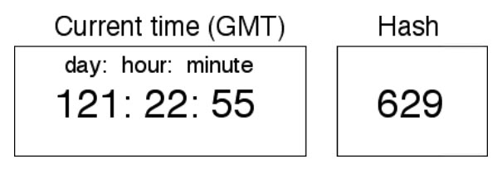

Fig 1 - Time Trap Display. This is an example of the frozen display on a time trap once the container is opened. The time the container was opened—ideally Greenwich Mean Time (GMT)—is displayed with 1 minute resolution, along with the hash associated with that time and the relevant seal/shipment. The “day” displayed is the day of the year (1-366). (Elapsed shipment time or local time can be used instead of GMT, but this requires clock synchronization between the shipping and receiving locations.) The hash will be wrong or absent, and/or the time will be wrong or absent, if an adversary opened the container or transport vehicle prior to the seal inspection. Nothing is shown on the display until the seal detects that the container has been opened.

