LAUR-98-9945

Rapid Sampling From Sealed Containers

Roger G. Johnston, Anthony R.E. Garcia, Ron K. Martinez, and Eric T. Baca
Advanced Chemical Diagnostics and Instrumentation
Los Alamos National Laboratory
MS J565, Los Alamos, NM 87545

ABSTRACT
We have developed eight different versions of portable tools for sampling from sealed containers. These tools allow the user to rapidly drill into a closed container, extract a sample of its contents (gas, liquid, or free-flowing powder), and permanently reseal the point of entry. This is accomplished without exposing the user or the environment to the container contents, even while drilling. The tools are inexpensive, small, and easy to use. They work with any battery-powered hand drill. This allows considerable safety, flexibility, and maneuverability. The tools also permit the user to rapidly attach plumbing, a pressure relief valve, alarms, or other instrumentation to a container. There are a variety of possible applications for these tools, including for waste management.

INTRODUCTION
It is often necessary to obtain a small sample of chemicals stored within sealed containers [1, 2]. This may be for purposes of identifying unknown contents, for verifying or archiving, or for monitoring the status of long-term stored wastes. Opening a sealed container and extracting a sample is often difficult, time-consuming, and hazardous. This is particularly the case when dealing with emergencies, unknown or hazardous materials, or containers that are pressurized, dented, or corroded. Even under ideal conditions, opening a waste container may result in personnel and the environment being exposed to volatile chemicals or fine powders.
We have developed eight different versions of inexpensive, portable tools that allow the user to rapidly drill into a closed container, extract a sample of the contents (liquid, gas, or free-flowing powder), and permanently reseal the point of entry. This occurs without opening the container, and without exposing the user or the environment to its contents--even while drilling. Containers made of almost any material can be sampled, with wall thicknesses up to 13 mm. Containers that can be sampled include 30- and 55-gallon drums, tanks, stainless steel vessels, cans, pipes, carboys, plastic bottles, artillery shells, and plastic or wooden barrels.
All of our sampling tools work with a common, battery-powered hand drill. This eliminates the need for power cords or heavy equipment, giving the user considerable flexibility and maneuverability. Samples can be taken from the top, bottom, or sides of a container. There is no need to access more than a few square centimeters of the container’s exterior. It is thus possible to sample from containers that are stacked, located in confined spaces, or otherwise less than fully accessible.
Each tool offers different advantages. Model A drills, samples, and reseals the container in a single step. It can be reused on different containers. Models B1 and B2 drill and tap a hole, then stay in place in the container wall. They allow multiple samples to be taken from the same container (even at a later date) without redrilling. Other versions of the B1 and B2 tools offer additional advantages.
These tools were originally developed for use by U.S. Special Forces. We envision a number of other possible applications including monitoring and venting of storage containers; transferring liquids; rinsing and flushing containers; assisting drug and environmental enforcement raids; checking containers at emergency and disaster sites; investigating suspected caches of chemical, nuclear, or biological agents destined for weapons of mass destruction; and rapidly neutralizing (introducing water into) ammonium nitrate-fuel oil (ANFO) barrels prepared as terrorist bombs.

CONVENTIONAL APPROACHES TO CONTAINER SAMPLING

Conventional Manual Samplers for Liquids
The most common method for sampling liquids from large sealed containers involves inserting a mechanical sampler (tube or scoop) through the bung or opening in the top of the container and transferring the collected sample to a storage bottle [1-3]. Devices for accomplishing this include commercial dip samplers, thieves, COLIWASAs, bomb samplers, weighted bottles, and bailers.
While this technique is straight forward, there are a number of serious disadvantages. The headspace gas cannot be sampled using this technique. Usually samples can only be taken through the top of the container. Immersing, then removing the tube or scoop may cause stratified container contents to mix. The sampler may catch on solid waste objects within the container. When the tube or scoop is withdrawn from the container, it is often difficult to transfer the sample to the sample bottle without dripping liquid chemical waste. Upon completion of the process, the tube or scoop must eventually be cleaned for reuse or discarded, further contributing to waste management problems.
Perhaps the most serious disadvantage to this type of manual sampling is that it requires opening a bung or container lid. This exposes the user and the environment to the headspace gases and any volatile chemicals in the container. It also exposes the container contents to substantial amounts of outside air. In the case of dented, old, or corroded containers, or containers under internal pressure or vacuum, opening the bung or lid can be unpleasant, difficult, and even dangerous.

Sampling Pumps
Manual or electrical pumps are a partial solution to some of the disadvantages of manual liquid sampling. They still, however, require opening a bung or lid to insert the plumbing. A sample of the container contents can then be pumped into a sample bottle. Release of the container headspace gas and of any volatile contents can still be a problem. Eventually, the pump and plumbing must be cleaned or discarded.

Container Breaching
An alternate approach to container sampling involves puncturing or drilling through the top or sides of a closed container, leaving the lid and bung sealed. Devices to do this are often based on a semi-portable pneumatically or electrically driven punch [4, 5]. They typically cost $1000 or more. Large, sophisticated, semi-automated systems for punching or drilling a hole in a 55-gallon drum [6, 7] cost hundreds of thousands of dollars.
Conventional container breaching devices rely on considerable force to puncture or drill through the container wall. They usually can sample only from relatively thin-walled containers such as 55-gallon drums. Some of these devices can only sample from the top of a container and are designed more for container venting than liquid sampling. Depending on the device, other disadvantages can include releasing volatile container contents during and/or after the drilling process; ineffective sealing of the breached hole; poor portability and maneuverability; long set-up times; complexity of operation and training; and intrinsic hazards from high voltage, pressurized gas cylinders, or large forces and torques. These instruments are all significantly limited in the number of containers that can be sampled in a specific amount of time. They cannot rapidly sample from sealed containers in confined spaces or in emergency situations.

Small Sampling Tools
Two recent U.S. patents (Clark and Kammeraad) involve small drilling tools for breaching containers [8, 9]. Neither tool appears to be commercially available. These inventions do not include any specific mechanism for drawing or collecting a sample after container breaching. Both tools fail to fully contain the kerf (shavings) generated during drilling or tapping through the container wall. The kerf may be contaminated with the container contents.
Other potential disadvantages of the Clark patent include difficulty in breaching thick-walled containers or containers made of hardened materials, the requirement for full access to the container perimeter, and/or poor sealing during the breaching process. Additional potential disadvantages of the Kammeraad tool include complexity of manufacture, difficulty in obtaining optimal operation when the wall thickness is unknown, potentially poor sealing during the drilling process, and/or damage to the container wall and bore hole.

THE LOS ALAMOS SAMPLING TOOLS

General Approach
In designing new tools for sampling from sealed containers, we focused on simple and low-tech approaches. We wanted to emphasize hands-on use. (Our tools, however, could also be used for remote sampling with some re-engineering.) With this in mind, the tools are intended to work with any commercial battery-powered hand drill. Such drills are familiar, safe, and easy to use. They involve only low voltages and modest forces and torques. Cost ranges from $50 to $300, depending on the model and features.
To avoid release of container contents during drilling, our tools use several different gaskets and seals. These are made of relatively inert materials. (See below.)
Another important design criterion was to be able to draw a sample from the container using the simplest possible method. To avoid the need for mechanical pumps, we decided to use Vacutainers™ manufactured by Becton-Dickinson (Franklin Lakes, NJ). These are evacuated glass tubes with silicone rubber septa. They are used by health care professionals for blood collection. When the septum is punctured by a syringe needle, the vacuum inside the Vacutainer sucks a fixed amount of the patient’s blood into the tube. When the syringe needle is withdrawn, the septum seals the blood sample safely inside the Vacutainer. This limits the chance of exposing medical personnel to pathogens that may be in the patient’s blood, and prevents the blood sample from becoming contaminated by the environment or excess oxygen.
In our tools, a fresh Vacutainer is used for each new sample. Plastic versions are available, but glass Vacutainers offer excellent chemical resistance, have good shelf life, and allow the collected sample to be fully visible, while protecting it from air and the environment. By loading the unused Vacutainers with chemical speciation paper (a litmus-type paper that changes color in the presence of certain chemicals), we can potentially identify certain chemicals in the field. In anticipation of this application, we are using transparent Vacutainers and have designed our tools to leave the collected sample visible at all times. Los Alamos National Laboratory already has speciation papers for certain actinides

Model A
With the Model A, the user drills, samples, and reseals the container in a single step. After inserting the back end of the tool into the chuck of a hand drill, the user presses the tool head against the container wall and drills through. Attached to the head is a silicone rubber sheet (with a center hole) that serves as a temporary gasket. The diameter of the hole drilled into the container wall is 3.2 mm.
After fully penetrating the container, the (hollow) drill bit assembly automatically retracts. The back end of the assembly contains a syringe needle which then punctures the septum of the Vacutainer in the rear of the tool. This causes the Vacutainer to suck a sample of the container contents through the side fill hole in the hollow drill-bit assembly. On completion of sampling, the (contaminated) drill bit is fully retracted into the tool for safety.
With the Vacutainer full, the hand drill’s continued rotation forces a piston forward, pressurizing a compartment that extrudes a flowable sealant, typically an inert, single-component siloxane or fluorinated-siloxane adhesive. This sealant permanently seals the entry hole. The sealant plug withstands 0.3 to 1.0 meter of head pressure (up to 5 kPa) prior to curing, depending on the container wall thickness and physical properties of the fluid contents. After curing, the plug holds against 5 meters or more of head pressure (27 kPa). Full curing typically requires 24 hours, although partial curing occurs within a few minutes.
Model A’s internal workings are automatic and invisible to the user, who simply runs the hand drill until a phosphorescent line painted on the Vacutainer housing is no longer visible. See figure 1. When that line has been covered by the tool’s body, drilling/sampling/resealing is complete. The user then walks away with the sample stored inside the tool’s Vacutainer, and the hole in the container wall plugged.
Model A can be used again on other containers if it is reloaded with an empty Vacutainer and fresh sealant. This takes less than 3 minutes, including cleaning if cross contamination with future samples is a concern. A freshly loaded Model A tool can sample from a 55-gallon drum in less than 15 seconds. For drilling through 100% glass containers, the drill bit must be replaced by a diamond core drill.
The Model A costs $650 each in quantities of 200 and weighs 0.75 kg. The maximum dimension prior to use is 305 mm. It can be used to sample from containers with wall thickness of nearly 0 mm to 13 mm.

Model B1
Model B1 uses a hollow, stainless steel self-tapping screw to drill and tap the container wall. The hole diameter is normally 4.7 mm, although smaller holes are possible. During the drilling and tapping process, the (silicone rubber) exterior septum seals against the container wall and against the threads of the self-tapping screw to prevent escape of the container contents. We took great care in choosing the diameter of the hole in the exterior septum. If it is too small, the exterior septum will be threaded by the self-tapping screw; this would permit the container

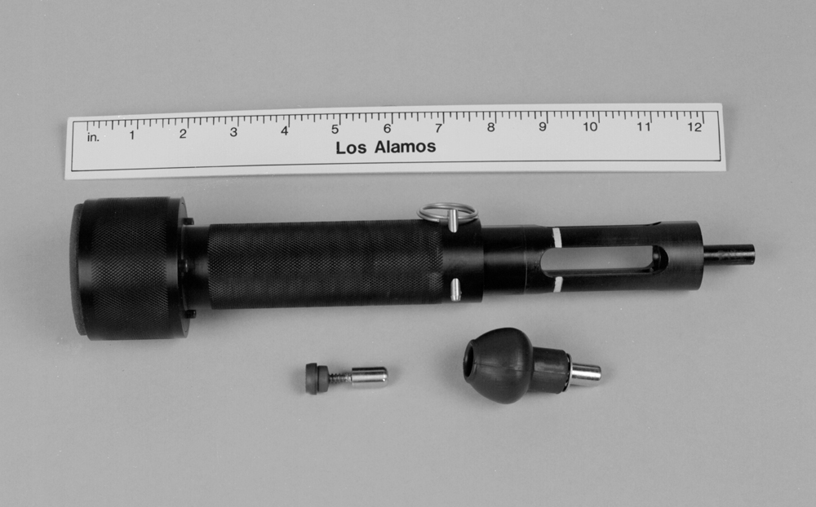

Fig. 1. Sealed-Container Sampling Tools—Model A (top), Model B1 (bottom left), and Model B2 (bottom right).

contents to escape by spiraling up the threads. Conversely, the container contents could escape if the hole is too large. Another function of the exterior septum is to trap and isolate the (potentially contaminated) kerf generated during the drilling/tapping process.
After the Model B1 tool reaches maximum penetration, the force from the compression of the exterior septum stalls the hand drill. At this point, the user stops the drill and releases the chuck, leaving the Model B1 tool in the container wall. See figure 2. Sampling is discussed below.

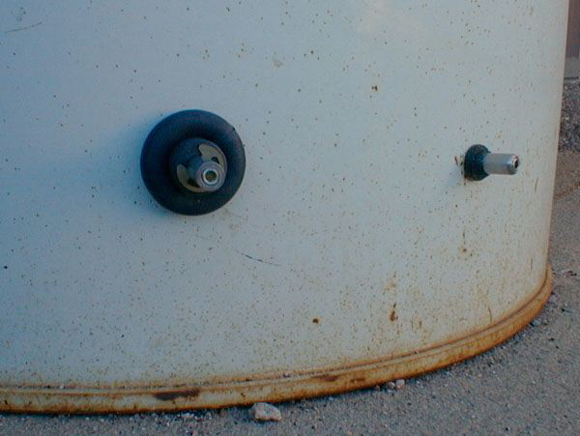

Fig. 2. Model B1, right, and Model B2, left, after being left behind in the wall of a 55-gallon drum filled with water. They showed no signs of leaking, aging, or corrosion after 6 months exposed to the elements.
Because of the good mechanical seal it makes, Model B1 can sample from containers with internal pressures up to 8 atmospheres (800 kPa). The exact maximum pressure depends on the container material, wall thickness, and contents. Containers with walls between 0.5 and 7.5 mm thick can be sampled. The Model B1 costs about $4 each in quantities of 5000. It has a length and weight of 35 mm and 9.3 gm, respectively. When left behind in the container wall, it sticks out 21 mm. Sampling from a 55-gallon drum takes less than 15 seconds, including set-up time.

Model B1-SF
Model B1-SF is a “semi-flush” version of the Model B1 tool. It sticks out only 10 mm from the container when embedded in the wall; the interior septum is actually inside the container at that point. Because of its lower profile, the Model B1-SF is usually not inserted directly into the chuck of the hand-drill. It is instead held by a hex-nut driver which is inserted into the drill chuck.
The Model B1-SF design includes a Teflon-tipped, stainless steel set screw. This can be threaded concentrically into the axis of the tool after sampling to serve as secondary containment. It protects against loss of container contents should the interior septum leak or degrade over time.
The Model B1-SF is 25 mm long and weighs only 6.1 gm. As a result, 70 of the tools--enough to sample 70 different containers--weigh less than 1 pound and can fit in a pants pocket.

Model B1-QC
Model B1 can be modified prior to use by adding a Quick Connect female connector. We designate this modified version as B1-QC. This modification permits the simple and rapid attachment of plumbing, alarms, pressure relief valves, or analytical instruments to the container. See figure 3. The quick-connect valve automatically opens when the male connector is inserted, and closes when it is withdrawn.

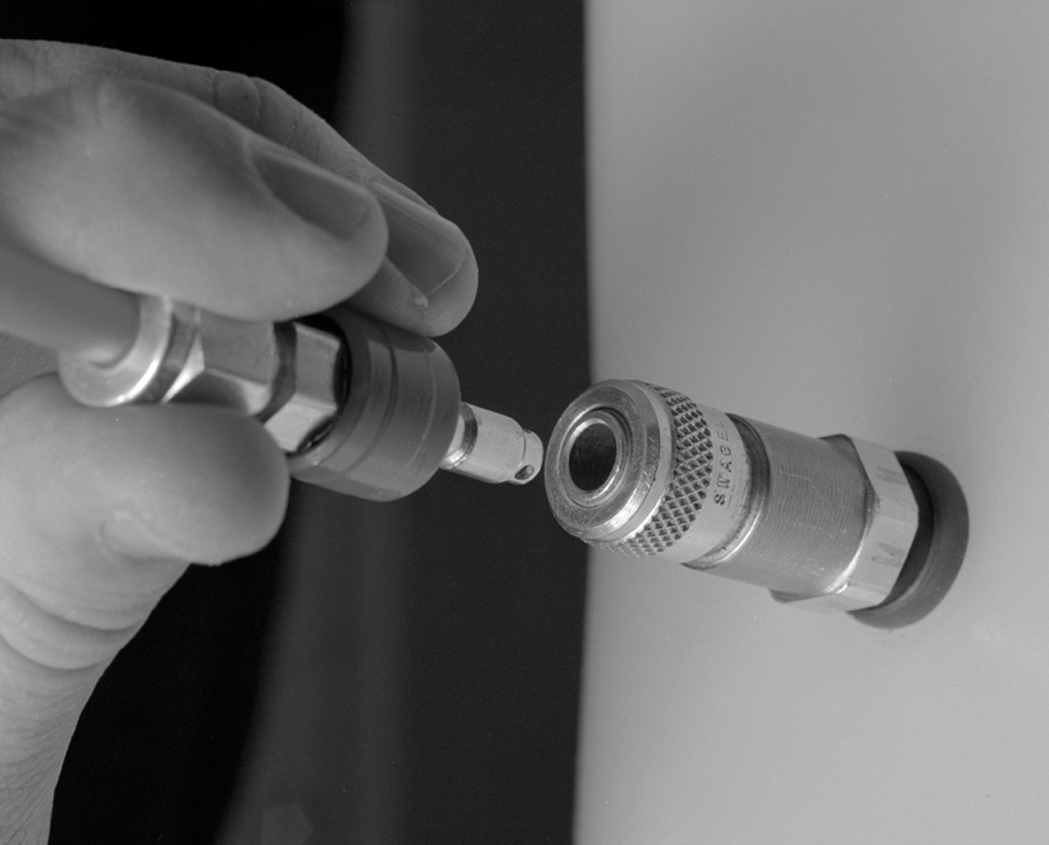

Fig. 3. Model B1-QC consists of a Model B1 modified to contain a commercial Quick Connect female connector. This makes it possible to quickly attach plumbing, valves, an alarm, or other instrumentation.
Model B1-SC
Model B1 can be made with an external left-handed thread, allowing the user to screw on a Teflon or stainless steel cap after sampling. An O-ring or adhesive then seals it against the container wall. The cap completely encloses the protruding tool, protecting it and serving as additional containment in case of leaks. (The left-handed thread prevents the user from inadvertently unscrewing the Model B1 tool from the container wall.).

Model B2
Model B2 is similar to Model B1 but it has adaptations that allow it to contain more kerf, and to cut more quickly through thicker walls (up to 13 mm) and hardened metals. It is the best tool to use on artillery shells. Instead of a self-tapping screw, the Model B2 tool uses a 10-24 or 10-32 (4.9 mm diameter) fluted commercial drap. (“Drap” = drill + tap.) Kerf is captured and moved out of the way by the initial rotation of a Paracril 0Z0 rubber bulb, called a “Chipmunk”. The Chipmunk also prevents escape of the container contents during the drilling/tapping process. At the completion of the drilling/tapping process, the Chipmunk is fully compressed against the container wall, with the kerf safely container in its “cheeks”. See figure 2. A (Viton) O-ring inside the Chipmunk makes the final seal against the container wall.
The Model B2 tool can sample through walls between 0.5 and 13.0 mm thick. It has a length and weight of 65 mm and 38.4 gm, respectively. It sticks out 45 mm when in place in the container wall. The estimated cost is $17 in quantities of 5000.
Other variations of the Model B2 tool are analogous to the modified versions of the B1 tool. The Model B2-QC incorporates a Quick Connect female connector to permit rapid attachment of plumbing, a pressure relief valve, or other devices. The Model B2-SC has an external left-handed thread to permit a secondary containment cap to be screwed on over it.

Sampler
To extract a sample, the user pushes a polycarbonate Sampler containing a Vacutainer against the B1 or B2 tool (or any of their variations). Figure 4 shows sampling from the Model B2 tool.

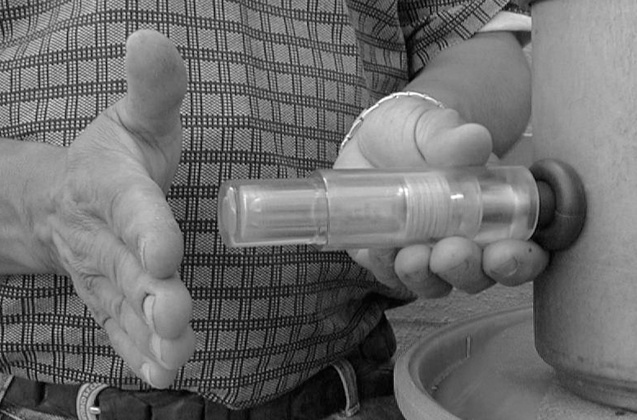

Fig. 4. Sampling with Model B2. The user pushes the clear, polycarbonate Sampler containing a Vacutainer onto the Model B2
(or B1) drill assembly and gives the back of the Sampler a shove.
A double needle in the Sampler simultaneously punctures the Vacutainer septum and the interior septum in the B1 or B2 tool (or variations). This allows the Vacutainer to suck a sample of the container contents through the side fill hole in the hollow self-tapping screw of the Model B1. For the Model B2, the drap is not hollow so the Vacutainer suction instead causes the fluid from the container to travel along the flutes of the drap into the tool housing.
When the Sampler is removed, the interior septum inside the B1 or B2 tool reseals. After removing the Vacutainer from the housing in the Sampler, a polycarbonate cap with a Viton O-ring can be snapped over the Vacutainer housing in the Sampler to provide secondary containment and to protect the Vacutainer.
By installing a fresh Vacutainer in the Sampler, the user can take a new sample, even from the same container. Vacutainers cost approximately 10¢ each in quantities of 1000. The (reusable) Sampler costs about $7 to manufacture in large quantities.

Training
Undergraduate students having no previous knowledge of our tools and no experience with container sampling have learned how to effectively sample using the Model B1 and B2 tools in under 2 minutes. It takes about 20 minutes to learn how to use, clean, and reload the Model A.
Models B1, B1-SF, B1-QC, B1-SC, B2, B2-QC, and B2-SC are intended for sampling from only one container each. For training purposes, however, these tools can be reused hundreds of times by simply driving the hand-drill backwards (counter-clockwise rotation) to unscrew them from the container wall. Of course, removing the tool leaves an unplugged hole in the container wall.

Inertness and Durability
All our sampling tools are constructed of relatively inert materials. Model A is made from anodized aluminum. It contains Viton O-rings, and uses an inert siloxane or fluorosiloxane sealant. Model B1 is constructed from stainless steel (including the self-tapping screw) and uses a silicon rubber exterior septum coated with silicon oil, and a PTFE-coated silicone rubber for the interior septum. The optional Teflon-tipped stainless steel set-screw for secondary containment on the B1-SF is also quite inert. Model B2 is also made from stainless steel and uses a Paracril 0Z0 Chipmunk, a Viton O-ring, and a PTFE-coated silicone rubber. For the Sampler, the only material momentarily in contact with the container contents is the stainless double syringe needle.
Materials with even greater inertness can be substituted, although this would increase the tool prices. Conversely, the use of less-inert materials would lower the tool prices, without substantially affecting most applications.
The chemical and environmental durability of the Model A plug has not been fully characterized. A fully cured siloxane plug, however, has maintained its integrity for over 12 months. The lifetime and durability of the Model B1 and B2 tools have also not been fully characterized. They may, however, be able to maintain their sealing integrity for a number of years. Both have been used to seal metal and polypropylene 55-gallon drums containing a 0.8 meter head of tap water. Even after sitting outdoors for 6 months at temperatures between -7°C and 36°C and being exposed to direct daily sunlight at an altitude of 2100 meters, the tools show no signs of ultraviolet damage, corrosion, or leakage. Figure 3 shows the tools after 6 months in a polypropylene 55-gallon drum. Additional samples can still be drawn through them.

FUTURE DIRECTIONS
The Model B1 and B2 tools, and all of their variations, can be made lighter and smaller. The problem with doing this, however, is that the tools becomes so small that they are difficult to handle, especially if the user wears protective gloves.
We are currently in the process of developing a version of the B1 tool that seats completely flush against the container wall. The portion of the tool held by the drill chuck will be designed to snap off after drilling and tapping is complete. There are also ways to hide evidence of sampling for covert applications.

CONCLUDING REMARKS
The Los Alamos container sampling tools permit simple, convenient, rapid, inexpensive, and safe sampling of the contents of a variety of sealed containers. It is easy to learn how to use the tools. Sampling can be done in the field by one person using only a battery-powered hand drill. Even moderately pressurized containers and containers with thick walls (up to 13 mm) made of hard metals can be sampled.
For 55-gallon drums, the number of containers that can be sampled per hour by one person varies between 20 and 200 per hour, depending on the tool, vs. 2 to 20 per hour using conventional methods.
The Los Alamos sampling tools also make it possible to quickly flush a container, or attach plumbing, pressure-relief values, or instrumentation.

ACKNOWLEDGMENTS
We benefited from the assistance of Frank Archuleta and from discussions with Butch Hager, Sam Borkowsky, Sam Freund, Kevin Grace, Anna Nogar, and David Volz.
REFERENCES

1. S.C. GOHEEN, S.K. FADEFF, G.M. MONG, D.S. SKLAREW, R.G. RILEY, B.L. THOMAS, and M. McCULLOCK, “DOE Methods for Evaluating Environmental and Waste Management Samples”, United States Department of Energy, Technical Report EM-0089T-Rev.2; DE95004428, Washington, D.C. (1994)

2. EPA, “Compendium of ERT Waste Sampling Procedures”, OSWER Directive
9360.4-07, Report EPA/540/P-91/008, Washington, D.C. (1991)

3. EPA, “Characterization of Hazardous Waste Sites-A Methods Manual: Volume 2, Available Sampling Method”, Report EPA/600/4-84-076, Washington, D.C. (1984)

4. AMERICLEAN, “Model 9500 Drum-Penetrating and Vent Unit”, http://www.mapworldtrade.com/Americlean/DrumPunch.htm (1998)

5. D.L. VOLZ, “The Los Alamos Remote Container Sampling Device”, http://www-emtd.lanl.gov/TD/WasteCharacterization/RemoteContainerSampling.html (1997)

6. E.O. BALLARD, E.D. DERR, K. GAINER, D.D. PIERCE, and P.P. PRINCE, “Drum Venting System Design and Fabrication”, Trans. Am. Nuclear Soc. 72, 98 (1995)

7. E.D. DERR, “Los Alamos (LANL) Drum-Venting System”,
http://www-emtd.lanl.gov/TD/WasteCharacterization/DrumVenting.html (1996)

8. J.E. CLARK, “Device for Draining Fluid from a Container”, U.S. Patent No. 5,558,140 (September 24, 1996)

9. D.A. KAMMERAAD, et al., “Tool and Method for Removing Fluid from a Container”, U.S. Patent No. 5,704,383 (January 6, 1998).

