LAUR-01-3726

The International Journal of Radioactive Material Transport 13, pp. 117-126 (2002)

THE “TOWN CRIER” APPROACH TO MONITORING

Roger G. Johnston, Ph.D., CPP
Anthony R.E. Garcia
Adam N. Pacheco

Vulnerability Assessment Team
Applied Monitoring and Transparency Laboratory
Los Alamos National Laboratory
MS J565, Los Alamos, NM 87545 USA
phone: 505-667-7414
fax: 505-665-4631
email: rogerj@lanl.gov

THE “TOWN CRIER” APPROACH TO MONITORING

Roger G. Johnston, Ph.D., CPP
Anthony R.E. Garcia
Adam N. Pacheco

Vulnerability Assessment Team
Applied Monitoring and Transparency Laboratory
Los Alamos National Laboratory
MS J565, Los Alamos, NM 87545 USA
phone: 505-667-7414
fax: 505-665-4631
email: rogerj@lanl.gov

Abstract:

This paper presents an unconventional approach to tamper and intrusion detection that has significant advantages for transport security, as well as for other aspects of domestic and international nuclear safeguards. The technique is called the “town crier” method. It avoids many of the problems associated with traditional approaches to tamper and intrusion detection. The town crier method involves continuous, real-time monitoring using simple hardware and an anti-alarm strategy. When operated in intrusion detection mode, it utilizes unidirectional, extremely low-bandwidth communication encrypted via a rigorously unbreakable cipher (the one-time keypad). In tamper-detection mode, the town crier method relies on anti-evidence to avoid many of the vulnerabilities of conventional tamper-indicating devices. We constructed a rudimentary town crier prototype system, and briefly tested it for monitoring cargo inside a truck. Preliminary results are encouraging.

INTRODUCTION

Detecting tampering and detecting unauthorized/undeclared intrusion are key functions of both domestic and international nuclear safeguards.(,) Tamper and intrusion detection are also of particular concern for the secure transport of radioactive materials. Tampering can be thought of as gaining unauthorized entry or access for nefarious purposes such as theft, diversion, espionage, sabotage, or vandalism. Tamper-indicating devices (“seals”) are designed to recognize tampering after the fact. Intrusion detectors, on the other hand, are meant to work in real-time: they report unauthorized access or entry as it happens. There are advantages and disadvantages to each approach.

It is difficult under the best of circumstances to provide reliable, unspoofable, cost-effective tamper or intrusion detection. In fact, it may not even be totally possible.() When the monitored assets are under transport, the problem is doubly complex because of mobility, as well as constraints on space, weight, personnel, and electrical power. Detecting tampering or intrusion for international safeguards purposes adds additional challenges. This is because the “adversary” is a nation (treaty signatory) with world-class resources that can be used to try to defeat the monitoring systems should it desire to cheat on the treaty or arms control agreement. Moreover, the adversary (not the protagonist) owns the assets of interest, the facility or transport vehicle that contains them, and must approve and have complete knowledge of all details of the monitoring hardware. This is backwards from conventional security applications such as domestic nuclear safeguards.

Given the difficulty of providing effective tamper or intrusion detection in general, and particularly for transport and treaty monitoring applications, it is useful to consider unconventional approaches. They can provide multiple options and enhanced flexibility. These alternative approaches may end up being simpler, more low-tech, and less likely to reveal classified or confidential information. As such, they may be more cost-effective and more negotiable for treaties or informal arms control agreements.() In addition, novel monitoring concepts can lead to fresh thinking that may be beneficial regardless of the hardware and methods that are ultimately deployed.

This paper concerns an alternate approach to tamper and intrusion detection: continuous, unidirectional, real-time, low-bandwidth, anti-alarm monitoring. This approach, which we call the “town crier” method, is meant to overcome the problems associated with conventional tamper and intrusion detection, especially for transport and treaty monitoring applications. It also addresses certain encryption, authentication, and steganography concerns. The town crier method can be applied to complete monitoring systems, or to sub-components such as tamper-indicating seals or intrusion sensors.

The paper is organized as follows: First there is a description of conventional approaches to tamper and intrusion detection, along with a brief discussion of their problems. The town crier method for intrusion detection is then described, along with a consideration of the one-time keypad. Using the town crier technique for tamper detection is discussed next. Finally, we describe a rudimentary prototype we have constructed, and present some very preliminary test results.

CONVENTIONAL APPROACHES TO TAMPER AND INTRUSION DETECTION

Tags and seals are often used (or considered) for domestic nuclear safeguards and for international treaty monitoring.(,) A tamper-indicating seal is a device for detecting tampering or unauthorized entry.(,) The most familiar everyday example of seals is probably that of the tamper-evident packaging found on over-the-counter pharmaceuticals. Unlike locks, seals do not attempt to delay or impede unauthorized access. Instead, they record that it took place. A tag is a device or intrinsic feature meant to uniquely identify (“fingerprint”) an object or container.() One common example is the license plate on a car.

With seals or (security) tags, the fact that tampering has occurred is stored until such time that the tag or seal can be inspected. This fact can be exploited by an adversary. Many of the most effective attacks on tags or seals involve an adversary letting the tag or seal detect the tampering, but then erasing or removing the stored information, i.e., the alarm condition, prior to inspection.

Intrusion detectors, in contrast to tags and seals, typically attempt to overcome the problem of storing the alarm condition by instead immediately sending a real-time alarm to some distant location when unauthorized access has been detected. The usual weakness in this approach is that the alarm signal can be blocked, leaving the intrusion undetected. It is common to attempt to overcome this problem by using encryption, authentication, or polling methods, but these create their own problems, as discussed below.

Figures 1-5 depict schematically the approaches used for conventional tamper detection and intrusion detection. Figure 1 shows the standard approach for active (that is, electronic) seals. The three major seal components are shown inside the rectangle and typically consist of a sensor to detect tampering, electronics or a central processing unit (microprocessor) to interpret the sensor data, and electronic storage to record the fact that tampering has occurred. In order to make a determination about tampering, the seal must be inspected. This involves reading the storage medium using an electronic or optical reader (verifier), or else visually examining the seal.

Disadvantages of active seals include the intensive labor needed to inspect them in person using well-trained inspectors, the resulting delay in detecting tampering, the relatively high cost of the seals (though they can be reused), their need for battery or electrical power, the problem (for international safeguards) of who owns, controls, and installs the seals, and myriad vulnerabilities.(-13) Possible ways to defeat an active seal can include (but are not limited to) counterfeiting the entire seal—or at least its perceived behavior such as its data output—to hide evidence of tampering, tampering with the seal’s components (sensor, CPU, or storage), interfering with the data communication lines inside the seal (the zigzag arrows in figure 1), disrupting the power supply, breaking any encryption or authentication cipher used by the seal, and compromising the electronic reader, seal inspector, seal data, or the installation process.()

Figure 2 shows the somewhat simpler design of a passive (non-electrical) tamper-indicating seal. In this case, the storage medium is integrated into the sensor. Typically, the body of the passive seal itself becomes irreversibly damaged when tampering has occurred, and (at least in theory) this permanently records that tampering has taken place. The major disadvantages of passive seals include the time and labor needed for inspection and training, complex protocol issues about how they are used for treaty monitoring, and their easy-to-exploit vulnerabilities.(Error: Reference source not found,,)

Note that figures 1 and 2 can also be considered schematics for security tags, not just seals. The reason is that security tags and seals are somewhat interchangeable. To be effective, a security tag must be able--like a seal--to detect tampering, such as when it has been lifted from one object and placed on another. A seal, on the other hand, is like a tag in that it needs some kind of unique identifier (“fingerprint”) so that an adversary cannot trivially replace it with a counterfeit. Often, whether a device is a security tag or a seal depends more on the user’s intent than on the hardware design. (There are other kinds of tags in addition to security tags that do not need to detect lifting, and thus are not so closely related to seals. Examples include labeling tags, product anti-counterfeiting tags, and buddy tags.)

Turning now to intrusion detection, figures 3 and 4 represent the common traditional approaches.() The intrusion detector in figure 3 consists of a sensor to watch for intrusion, a central processing unit (CPU) or microprocessor to interpret the sensor data, and an alarm should intrusion be detected. When intrusion is detected, the alarm signal is sent to a remote headquarters (HQ) or security station for interpretation and response. The common disadvantages of intrusion alarms of the sort shown in figure 3 include their need for battery or electrical power, the logistics associated with maintaining an open communications channel to send the alarm, the problems of interpreting an alarm at HQ and responding appropriately, inadvertent and deliberate false alarming, and a wide range of security vulnerabilities.(Error: Reference source not found,)

One of the easiest attacks on an intrusion detector of the type shown in figure 3 involves an intruder blocking the alarm so that his presence goes undetected at HQ. Figure 4 incorporates one common countermeasure to this vulnerability that is used in more sophisticated intrusion detectors and complex monitoring systems. To prevent an adversary from simply blocking the alarm signal, headquarters (HQ) periodically or semi-continuously polls the device or system to check if intrusion has occurred. The device or system responds with an encrypted or authenticated response.(Error: Reference source not found) Unless the adversary understands or breaks the cipher being used for the data encryption or authentication, he cannot (at least in theory) easily counterfeit the response in order to fool HQ into thinking no intrusion has occurred.

Typical disadvantages of intrusion detectors or monitoring systems such as that depicted in figure 4 include their complexity, high cost, need for battery or electrical power, the logistics associated with maintaining two-way communication, the problems of interpreting the system response at HQ and responding appropriately, inadvertent and deliberate false alarming, and a wide variety of security vulnerabilities and real-world reliability problems associated with the increased complexity.(Error: Reference source not found) Moreover, the encryption or authentication cipher can be compromised, broken, or bypassed any number of different ways, sometimes by even relatively unsophisticated adversaries.() There are also serious challenges associated with protecting the sensors, the encryption/authentication electronics, the network, the cipher keys, and HQ itself from compromise or tampering.

Three other issues are of particular concern for the polled/encrypted approach to monitoring shown in figure 4. The first issue is the frequency of polling. If an adversary can tamper with the system before the next polling, his intrusion may go unreported. The second issue concerns the negotiability of the system for international safeguards. Due to safety, espionage, and security concerns, the host (inspected) nation may not be comfortable with the idea of data lines controlled by foreign inspectors going both into and out of its nuclear facility or transport vehicle, or with inspectors being able to communicate directly with the monitoring system. The third problem has to do with espionage concerns related to the use of data encryption or authentication. This is discussed below.

Figure 5 shows a different kind of traditional approach to intrusion monitoring. With this technique, raw sensor data, sometimes encrypted or authenticated, are sent continuously to headquarters (HQ) for interpretation. A closed-circuit camera surveillance system is an example of this type of intrusion monitoring. Typical problems with this type of monitoring include those discussed above for figure 4, plus the serious problems of constantly monitoring and correctly interpreting the streams of high-bandwidth sensor data at HQ and responding appropriately, and concerns by the host nation during treaty monitoring that the sensor(s) will inadvertently “see” something that is secret. Moreover, it may be difficult to monitor items during transport using the approach of figure 5 due to the need to continually maintain high bandwidth communications. It is also quite complicated and expensive to operate large numbers of such monitoring systems simultaneously.

Another problem with the systems shown in Figures 4 and 5, at least for international safeguards, is that the host (inspected nation) may be opposed to the idea of encrypted data which it cannot read leaving the facility. This situation arises when symmetric-key ciphers are used.() Employing more modern, asymmetric-key encryption or authentication algorithms can help avoid this problem. Asymmetric-key ciphers have separate encryption and decryption keys. They permit the host to use the decryption key to check that the encryption or authentication has been done properly. The host cannot, however, easily counterfeit monitoring data without breaking the cipher, stealing the encryption key, or compromising the monitoring hardware or security personnel. Disadvantages of the most sophisticated asymmetric-key ciphers include computational intensiveness, complexity in negotiating how the keys will be distributed and secured for treaty monitoring, and the fact that such ciphers can be broken.(Error: Reference source not found,Error: Reference source not found) Moreover, there will tend to be problems with proprietary, export control, and national security issues when sophisticated ciphers are applied for international safeguards applications.

Regardless of what ciphers are used, there is the problem of steganograpy, i.e., the art of hiding information.() It will usually be possible for a monitoring system to hide information inside the raw monitoring data using steganographic techniques prior to encryption or authentication. If the monitoring system transmits large amounts of data (high bandwidth), an extensive amount of classified information could be lost without the knowledge of the host.

Hybrid systems that combine some of the features of figures 1-5 are also possible. Complex systems can incorporate all the features depicted in figures 3-5, including alarms, polling, and transmission of high bandwidth sensor data. In general, hybrid systems do not automatically avoid the problems associated with the individual monitoring methods of figures 1-5.

For treaty monitoring purposes, the tamper and intrusion detection methods depicted in figures 1-5 (including hybrid systems) have an additional serious problem. They typically fail to effectively address what can be called “The Fundamental Dilemma of International Treaty Monitoring”: If the inspectors provide the monitoring hardware, the host (inspected) party worries about safety, espionage, and security. But if the host provides the hardware, the inspectors don’t trust its readings. If the Fundamental Dilemma is not explicitly dealt with, the negotiability and effectiveness of a particular monitoring approach is problematic. One common idea for dealing with the Dilemma is through so-called “dual control”, where both sides jointly secure monitoring hardware. Dual control, however, is a complicated and largely unsolved problem, and has been the subject of remarkably little research or analysis.

THE “TOWN CRIER” APPROACH FOR INTRUSION DETECTION

The problems with the conventional approaches to tamper and intrusion detection discussed so far are serious. An alternate approach to intrusion detection is shown in figure 6. This “town crier” method uses a continuous, unidirectional, real-time monitoring technique. Rather than storing information about intrusion (which can be erased), or sounding a real-time alarm (which can be blocked), or maintaining complex two-way communications, or needing to process continuous high bandwidth data at a distant location, or dealing with the threat of steganography or the problems and vulnerabilities of computational ciphers, this approach involves a simple, very low bandwidth “anti-alarm”. The anti-alarm is a frequent and periodic “All OK” signal that indicates the absence of intrusion. Under this approach, the failure of the “All OK” signals to arrive, at least for any significant amount of time, must be taken to mean there has been intrusion.

For most applications, the bandwidth required for the anti-alarm will be between 1 bit and 1 byte per second. Even lower transmission rates, however, are possible, especially if it takes more than 1 second to attack the system. Because of this low bandwidth, the “All OK” signal is ideal for encryption using a one-time keypad. A “one-time keypad”, also called a “one-time pad” or “Vernam cipher”, uses a random key having the same length as the message to be encrypted.() This key can never be reused. One-time keypads are not practical for encrypting large amounts of data because the key is so long. One-time keypads, however, are practical for low bandwidth data. A one-time keypad has the advantage of being the only encryption algorithm that can be shown mathematically to be unbreakable.(,) It is also quite simple in that it uses a lookup table, instead of the massive computation required by other encryption schemes. This is a definite advantage for hardware simplicity, cost effectiveness, and treaty negotiability. The size of the lookup table is fairly modest by today’s standards: 4 MB for a year of monitoring at 1 bit/sec, and 32 MB at 1 byte/sec (less with data compression). Moreover, unlike certain other ciphers, use of a one-time keypad for international safeguards does not introduce proprietary or export control issues, nor does it compromise domestic security by giving away domestic security hardware and approaches.

The anti-alarm approach considered here is a little like the town crier concept used in the past by soldiers and medieval towns for security.() The town crier would call out each hour (sometimes in code) that, for example, “10 o’clock and All’s Well!”. If invaders should overpower him before he could sound an alarm, the absence of the “All OK” signal (and the crier’s familiar voice) at the appointed time would indicate trouble.

The town crier type of intrusion detection depicted schematically in figure 6 occurs continuously and in real-time. There is no storage of an alarm condition inside the monitoring system itself. In effect, sending the encrypted “All OK” anti-alarm to HQ is a way to transfer the alarm condition to a safe location, avoiding the problem of securing it, as is attempted in figures 1, 2, and 4.

Receiving the “All OK” signal at HQ (or a security or inspector’s station) can be fully automated. A computer can easily check the incoming data against its copy of the one-time keypad to verify that the correct “All OK” signal continues to be sent. The computer can alert HQ personnel if the “All OK” signal fails to appear on time.

The major advantages of the “town crier” approach to intrusion detection include:

• It permits continuous monitoring.

• It operates in real-time, and can alarm in real-time, allowing immediate response.

• It is simple, open, and transparent.

• For reasons of security, simplicity, and negotiability, no sensor data or other information (other than the low-bandwidth “All OK” signal) is released from the monitoring system during the monitoring process. This provides little opportunity to sneak classified data out of the facility or transport vehicle being monitored.

• Because of this low bandwidth, it should be possible to monitor large numbers of moving vehicles, ships, or cargo containers simultaneously.

• For reasons of security, simplicity, and negotiability, there is no communication into the monitoring system during the monitoring process. In other words, the town crier approach is unidirectional.

• HQ remains passive and silent throughout the monitoring (as long as no intrusion is detected). As a result, any failures or deficiencies of hardware or personnel inside HQ--and perhaps even HQ’s location--remain unknown to the adversary.

• Decisions about whether intrusion has occurred are automatically made locally by the monitoring system, rather than at a distant HQ. The decision-making process is protected by the monitoring system itself in that it monitors itself for tampering.

• The data coming from the system (“All OK” signals) can be publicly broadcast. There is no need to keep the signals secret, or to secure the transmission channel, even when the signals emanate from a high security nuclear facility.

• It may be desirable for security and counterterrorism purposes not to let the general public know that a truck, railcar, or ship is carrying radioactive materials. It is relatively easy to hide a byte/second (or lower bandwidth) transmission in amongst general communications traffic. This is in contrast to a blatant high-bandwidth signal (often considered for conventional transport intrusion detection) that might call undue attention to the transport vehicle and its contents.

• For treaty monitoring, this approach is well suited to having 100% host-provided and host-controlled monitoring hardware, with the one-time keypad provided by the inspectors at monitoring startup time.() There is little need for troublesome dual control of monitoring hardware.

• The simplicity of the approach permits the use of low-cost, commercial off the shelf (COTS) hardware. This makes it economical in treaty monitoring for the host (inspected nation) to present multiple copies of the monitoring system components or subsystems to the inspectors. The inspectors can randomly choose at the last minute which of these get installed and which they can take home to reverse engineer in an attempt to detect tampering.(Error: Reference source not found) At the end of a monitoring phase, moreover, the inspectors can keep the actual monitoring system, again for later analysis. Because the host nation built and controlled the monitoring system, it has fewer concerns about safety, espionage, or the release of classified information.(Error: Reference source not found)

A major disadvantage of the town crier approach is the need for continuous, highly reliable transmission of the (low-bandwidth) “All-OK” signals. (This not an issue for tamper detection, discussed below.) Indeed, the inadvertent loss of signal for longer than the time reasonably needed by an adversary to surreptitiously execute an attack must be taken to mean that intrusion has occurred. If the transport vehicle is properly designed, however, a successful surreptitious attack should be far from instantaneous. Moreover, communication reliability can, if necessary, be enhanced by using redundant, dissimilar channels of low-bandwidth communication to send the same “All OK” signal. Only one of the channels needs to get through at any given time. Depending on whether the monitored assets are stationary or under transport, some possible communication channels include an electrical wire, fiber optics, radio signals (including short-wave), cell phones, the Internet, acoustic/infrasound/ultrasonic signals, flashing lights or displays, laser beams, and mechanical signs.

Another significant disadvantage of the town crier approach is that it does not provide inspectors or security personnel with an immediate indication of what specific event or activity led to intrusion being reported. On the other hand, they can eventually gain such information when allowed final access to the monitoring system to observe the recorded sensor data. This sensor data is for diagnostic purposes only, however, because its veracity is not guaranteed, given that intrusion has been reported.

THE “TOWN CRIER” APPROACH FOR TAMPER DETECTION

Instead of using the town crier monitoring system as a (real-time) intrusion detector, it can also be used as a (delayed response) tamper detector. Unlike the seal methods shown in figures 1 and 2, however, this approach does not try to store the alarm (tampering) condition, which is the chief vulnerability for most seals. Instead, the equivalent of an anti-alarm is used. At startup time, security personnel (or treaty inspectors) input a single, short random number known only to them. Should tampering be detected, the system immediately erases this number. When security personnel (or inspectors) return to re-examine the system, the absence of the correct random number means that tampering has occurred. The monitoring system can recognize authorized security personnel or inspectors through a password sent remotely via a radio frequency or infrared signal, or by a hard-wired external keypad. An adversary using the wrong password would cause the stored random number to be immediately erased.

There is no easy way for an intruder to erase the evidence of tampering, because the unauthorized access itself causes an erasure of the stored random number before the intruder can determine what it is. Note that this approach is different than the idea of the monitoring system deleting the encryption or authentication key when tampering is detected; such a strategy is often used by conventional electronic seals and monitoring systems that transmit encrypted data to the outside world. Their encryption/authentication key is not as secure to begin with because the hardware has been telling the outside world bits of information (through its data transmissions) that can be exploited by cryptanalysts to try to break the cipher. With town crier tamper detection, in contrast, no hints are provided to the outside world about the random number stored within.

THE “TOWN CRIER” PROTOTYPE

The town crier concept was briefly demonstrated in a (stationary) nuclear materials storage magazine at the Pantex Plant in Amarillo, Texas.(Error: Reference source not found) We have since developed an easier to use, though still rudimentary prototype that can operate in either intrusion or tamper detection mode for monitoring cargo inside a truck.

There are a number of serious problems and constraints with our prototype. Because of the very limited funding available for this project, it was assembled with the assistance of relatively inexperienced undergraduate students, and was constructed from surplus and borrowed inexpensive hardware. Much of the hardware, including most of the sensors, are not intended for security applications. Indeed, we use several devices made by Vernier Software and Technology, Inc. that are actually low-cost science lab equipment meant for high school students. Another serious constraint is that the amount of time available for testing our prototype was severely limited. Furthermore, the maximum rf transmission range of only 50 meters for our “All OK” signal is far too limited for practical transport applications involving intrusion monitoring. For tamper detection, however, a range of 50 meters is more than adequate since the cargo can come to rest in front of security personnel or inspectors at its final destination before they check for tampering.

Given these problems and constraints, we do not consider our current prototype to be ready for practical use, anywhere near robust and reliable enough for real-world applications, or even developed enough to merit extensive testing. Nevertheless, we believe that the performance of the current prototype, crude as it is, does suggest that the town crier concept may indeed be feasible for real-world applications.

Our prototype system was built around two Apple iBook notebook computers. The software for both computers was written in REALbasic 3.5 (Real Software, Inc.), a cross-platform, object-oriented BASIC development environment and compiler with extensive graphical user interface (GUI) tools.

One of the iBook computers, called the “Sender” computer, is located inside the truck to monitor the security sensors and transmit wireless radiofrequency (rf) signals to the “Receiver” computer. The Receiver computer remains outside the truck to receive rf signals from the Sender computer.

Each iBook has an internal Apple AirPort card for transmitting or receiving 2.4 GHz spread spectrum rf signals at 15 dBm. No government communications license is required to operate the AirPort cards. They are capable of transmitting up to 11 Mbps, although our “ALL OK” signal requires only 1 byte per second. Maximum nominal transmission distance was found to be 50 meters. No antennas were used. The AirPort card on the Sender computer had to transmit through the metal encased cargo area of the truck, while the Receiver computer was typically located inside a building (when the truck was stationary), or inside an escort automobile (when the truck was in motion).

All rf signals were sent without redundancy. Thus, the appropriate one-time “All OK” byte was transmitted only once each second. Presumably greater signal reliability would be possible if each “All OK” byte were to be broadcast dozens or hundreds of times during its one second lifetime.

Our prototype town crier monitoring system was installed inside a salvaged, 1989 K30 Chevrolet delivery truck with a somewhat light-tight cargo area. See figure 7.

The 120V, 60Hz AC power for the monitoring system was provided by a Galaxy 1500 Watt DC to AC Power converter that ran off the truck battery, although the nominal total power requirements for all the hardware used inside the truck (including the iBook computer) is less than 24 Watts, half of which are needed by the Infrared (IR) illuminator to provide lighting for the video camera.

The monitoring system inside the truck consisted of the following:

• the Sender iBook notebook computer to monitor the sensors, detect unauthorized access to the truck and act accordingly, plus transmit rf signals

• a Vernier Labpro Analog to Digital Converter & Computer Interface to read the sensors

• a Vernier MG-BTA Magnetic Sensor to detect the opening of the truck backdoor

• a Vernier LS-BTA Light Sensor to detect changes in ambient lighting (such as the appearance of daylight) inside the cargo area

• a Vernier MB-BTD Ultrasonic Motion Detector to detect relative motion inside the truck

• a SuperCircuits PC-21XP2 monochrome pinhole camera to monitor the cargo, iBook computer, and sensors

• a ICU Security DVMD-1 Digital Video Motion Detector

• a SuperCircuits Infrared illuminator

• a Visonic DUET Combination Passive Infrared Detector and 10.525 GHz Microwave Motion Detector (PIR/MW) to detect movement and the presence of people

The various sensors are polled by the Sender computer in a random, constantly changing order, typically 5-10 sensor readings per second. Any sensor reading above the allowed threshold is interpreted by the monitoring program as intrusion or tampering, and the one-time pad or stored random number, respectively, is then quickly erased. Similarly, any attempt to move the computer cursor, click the mouse, depress keys on the keyboard, insert or eject removable media, halt the program, or shutdown/powerdown the computer is also interpreted almost immediately by the monitoring program as tampering or intrusion.

Other types of sensors such as magnetometers, force sensors, microphones, and photocells also appeared to work well with our prototype for monitoring stationary assets, but were found not to be reliable when the truck was in motion, primarily due to its worn suspension that made for a noisy and rough ride. One of the attractive attributes of the prototype system is that is can readily accept different, or additional sensors without modifying or re-compiling the software.

Figures 8 and 9 show the monitoring hardware inside the truck. The “cargo” used for tests and demonstrations was an empty ALR8 container, typically used to store plutonium pits. The ALR8 was strapped tightly into a holding pallet, which in turn was bolted to the floor of the truck. Preventing shifting of the cargo during monitoring is important--at least for the sensors used in these experiments--because major cargo movement could be misinterpreted as intrusion or tampering.

Most of the monitoring hardware, including the Sender computer, is closely mounted on the frame of the container pallet. This allows the video camera and other sensors to more easily watch the ALR8 container, each other, and the Sender computer. Moreover, by rigidly attaching the IR illuminator and video camera to the frame of the pallet, jolts and vibrations experienced by the ALR8 due to truck motion and road bumps are not interpreted by the video motion detector (VMD) as a video scene change.

Excluding the ALR8 and its pallet, the total cost of the monitoring hardware inside the truck was $3400 (in quantities of one). If the video motion detector is eliminated, the cost goes down to only $1800. The only hardware required at the receiving end of the town crier prototype is the Receiver iBook notebook computer ($1200), which could theoretically monitor signals from multiple Sender computers. Devoting an entire notebook computer to the Receiver task for a single truck is somewhat extravagant since the Receiver computer does little more than wait for signals from the Sender computer and compare them with what is expected. Both the Sender and Receive computers could be replaced with smaller and cheaper microprocessors.

EXPERIMENTAL RESULTS

Tables 1 and 2 summarize the preliminary tests on the town crier prototype for intrusion monitoring. Results are shown for when the truck was stationary (table 1), as well as for when it was driven on public roads at speeds up to 80 km/hour (table 2). Frequent turns and hills were encountered during the latter.

We focused primarily on intrusion detection, rather than tamper detection. This is because the reliability of the continuous rf “All OK” transmissions used for intrusion detection was a significant unknown. Otherwise, the two modes are virtually identical in how they interact with the sensors, plus they share 90% of the same software code.

For the intrusion monitoring of tables 1 and 2, we were able to acquire much more data with the truck stationary than when it was in motion because the latter required continually following the truck with an escort vehicle (containing the Receiver computer) at a distance of less than 50 meters. The Receiver computer could have remained stationary if we had the time or funding to exploit other, longer-range wireless technologies.

Combining tables 1 and 2, it can be seen that there was only one missing “All OK” signal, lasting but 1 second, out of 616322 total seconds (171 hours) of monitoring. It is doubtful that an adversary could easily attack the monitoring system, fool the sensors and Sender computer, gain access to the one-time keypad, and begin counterfeiting the “All OK” signals during this one second of lost signal.

All the intrusion attempts summarized in tables 1 and 2 were detected. For those in table 2, the truck was brought to a stop before entry was attempted in 3 of the 4 attempts. In the remaining intrusion test, one of the passengers entered the cargo area of the truck from the passenger compartment while the truck was in motion, and his intrusion was immediately detected.

In addition to the results summarized in the tables, 30 additional tampering or intrusion attempts were all also successfully detected for very short-term monitoring experiments. In fact, the prototype has never failed to detect a person entering the truck’s cargo area. While this is encouraging, it certainly cannot be considered a comprehensive test of security. No subtle attacks on the truck were attempted; all tampering/intrusion events involved a single individual entering the truck cargo area by either raising the rear truck door, or by entering from the driver’s compartment. We believe attempts to cut a hole in the truck floor, wall, or ceiling would also be detected, but this has not been tested.

CONCLUDING REMARKS

Conventional approaches to tamper and intrusion detection have significant disadvantages and vulnerabilities. This paper presented an alternative approach, called the “town crier” method. For intrusion detection, it is based on the use of (1) an unbreakable one-time keypad, (2) continuous, real-time monitoring, (3) an “anti-alarm” or “ALL OK” signal that indicates the absence of intrusion, and (4) very low bandwidth, one-way communication. As discussed in this paper, this approach is likely to be both simpler and fundamentally more secure for transport applications than traditional real-time monitoring concepts. It may also be better suited to simultaneously monitoring large numbers of vehicles or transportainers, due to attribute (4).

For tamper detection (not in real-time), the town crier monitoring requires no continuous communication with the outside world. Tampering is instead noted at inspection time when the stored, secret random number is found to have been erased. (In effect, the “town crier” tamper detection system waits until it is queried at the end before sounding or not sounding the “All OK” signal.) Intruders don’t know how to spoof the system because their unauthorized access rapidly erases the random number known only to the cargo owner. Unlike traditional truck or transportainer seals, moreover, this approach shows no evidence outside the truck or transportainer that tamper detection is underway.

For treaty monitoring applications, the town crier approach, whether in tamper or intrusion detection mode, permits the monitoring hardware to be provided and entirely controlled by the host (inspected) nation. Inspectors may nevertheless potentially have confidence in the veracity of the monitoring for reasons alluded to in this paper, but also discussed in more detail elsewhere.(Error: Reference source not found)

Finally, it is worth noting that the town crier approach can be applied both to complex, integrated, multi-component monitoring systems, as well as individual monitoring devices like seals or intrusion sensors. It is easy, for example, to imagine a storage vault or transport vehicle full of one-time keypad “seals” each monitoring a different container for tampering. The volume could be watched over by a single photosensor or video camera. As long as there is no tampering, each seal would flash its (LED) light at a random, unpredictable time (or with a characteristic modulation) given by the unique one-time keypad stored inside it. This light flash is the town crier “All OK” signal. Should tampering be detected by one of the seals, it will signal this fact by failing to send the correct “All OK” signal, and this will be noted by the computer that operates the photosensor or video camera watching the scene.

ACKNOWLEDGEMENTS

Eric Gerdes and Jim Doyle made important contributions to the development of these ideas. Ron Martinez and Sharon Seitz assisted with the experimental work. Morten Bremer Maerli provided useful comments and suggestions.
Table 1 - Experimental results for intrusion detection using the town crier prototype in a stationary truck.
________________________________________

Longest continuous monitoring time: 100 hours

Cumulative monitoring time: 168 hours (604800 secs = 7 days)

Number of “All OK” signals not received: 1 out of 604800

Number of false alarms: 0 in 604800 secs

Intrusions detected: 12 of 12 incidents

Table 2 - Experimental results for intrusion detection using the town crier prototype in a moving truck.
________________________________________

Longest continuous monitoring time: 2 hours

Cumulative monitoring time: 3.2 hours (11522 secs)

Number of “All OK” signals not received: 0 out of 11522

Number of false alarms: 0 in 11522 secs

Intrusions detected: 4 of 4 incidents

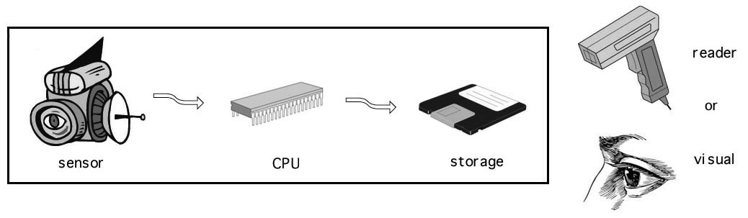

Figure 1 - Schematic of a typical active (electronic) seal. The seal itself (inside the rectangle) consists of a sensor to detect tampering, a central processing unit (CPU) to interpret the sensor data, and a storage element to record when tampering has been detected. Tampering, however, is not recognized until the seal is interrogated at inspection time with a reader (“verifier”), or by eye.

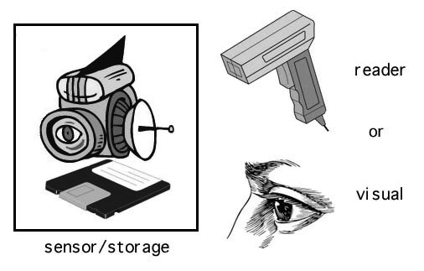

Figure 2 - Schematic of a standard passive seal. The sensor and recording medium are usually integrated, and are often the body of the seal itself.

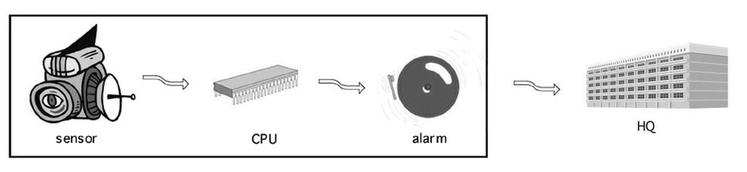

Figure 3 - Schematic of the most common type of intrusion detector (“burglar alarm”). The sensor watches for intrusion. Its data is analyzed by a microprocessor or central processing unit (CPU). If intrusion is detected, an alarm signal is generated and sent to a distant headquarters (HQ) or security station.

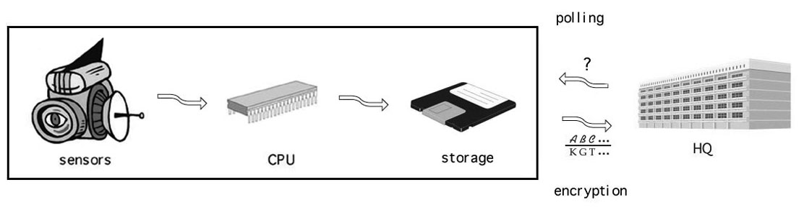

Figure 4 - Schematic of more complex intrusion detectors and monitoring systems. There is no alarm per se. Instead, information that intrusion has occurred is stored in the storage element. Headquarters (HQ) periodically polls the device or system to check if intrusion has occurred. The device or system responds with an encrypted or authenticated response (based on what is in storage) that indicates whether or not intrusion has taken place.



Figure 5 - Schematic of a monitoring system based on a continuous sensor feed. The high-bandwidth sensor data (perhaps encrypted or authenticated) is sent continuously to headquarters (HQ) or a security station for interpretation.

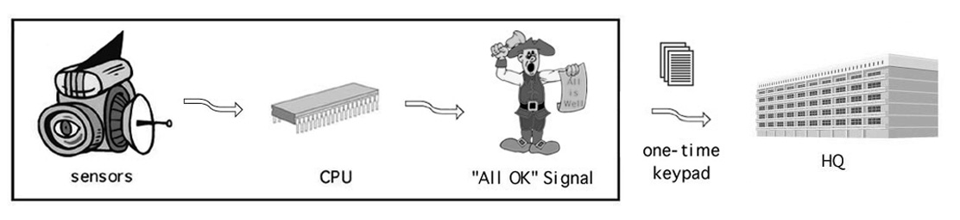

Figure 6 - Schematic of the town crier approach to intrusion monitoring. As long as no intrusion is detected, an “All OK” signal (anti-alarm) is periodically and automatically sent to headquarters (HQ). This low-bandwidth “ALL OK” signal can be encrypted using a one-time keypad cipher so that adversaries cannot counterfeit it. Should the “ALL OK” signal fail to appear, or should the wrong data be sent, HQ will know there is trouble. There is no communication from HQ to the monitoring hardware.



Figure 7 - The truck used for tests of the town crier prototype.

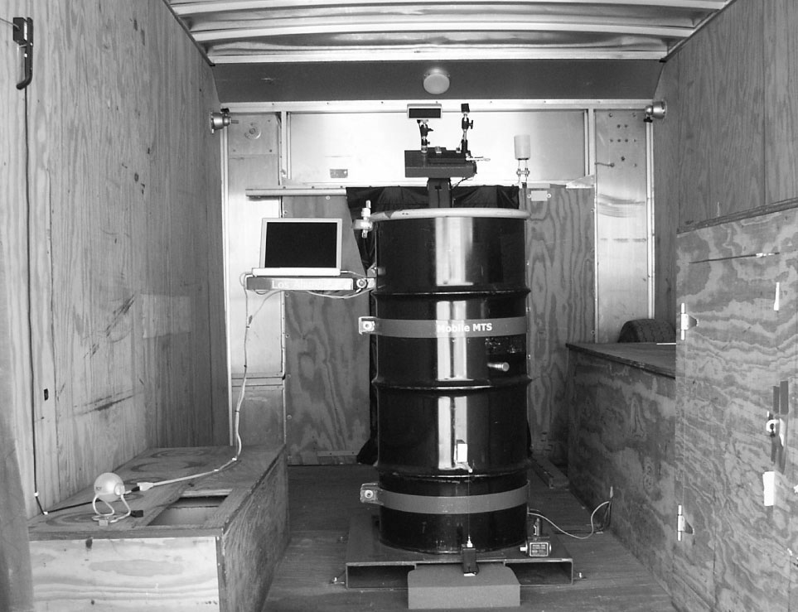

Figure 8 - The cargo area, as viewed from the rear of the truck. The ALR8 container, its pallet, the Sender notebook computer, and various sensors can be seen. Plywood lined the metal interior of much of the truck.

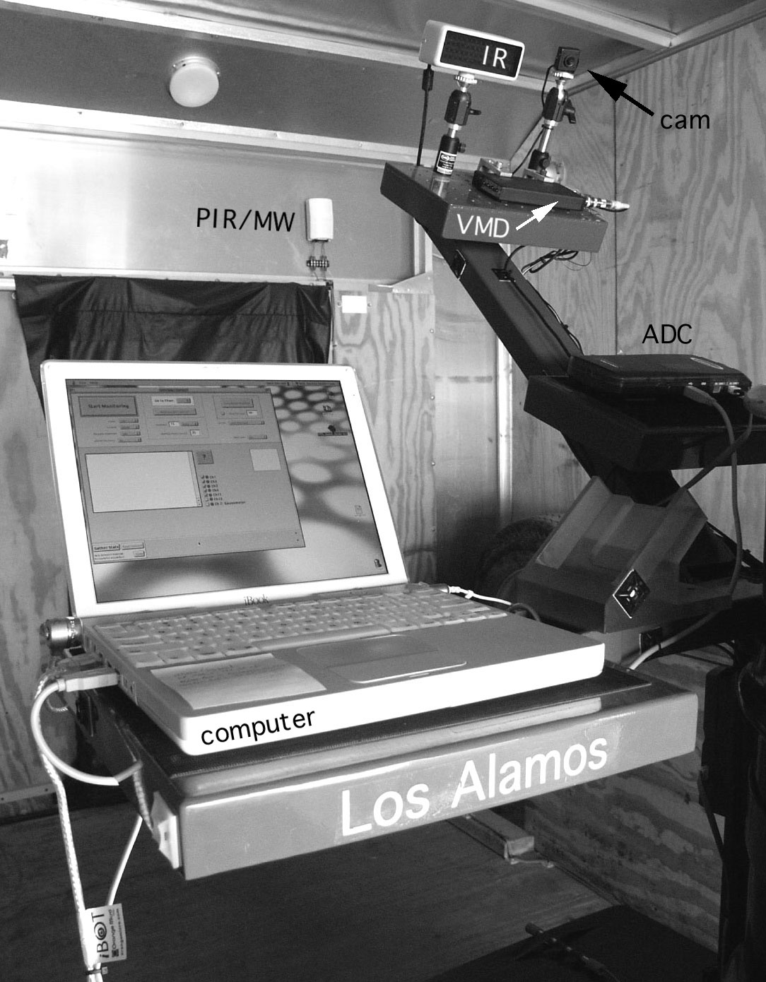

Figure 9 - A close-up of the Sender computer and some of the monitoring hardware. PIR/MW=passive infrared/microwave motion sensor, IR=infrared illuminator, cam=pinhole video camera, VMD=video motion detector, ADC=analog to digital converter.

Johnston, R.G. Tamper Detection for Safeguards and Treaty Monitoring: Fantasies, Realities, and Potentials, The Nonproliferation Review 8(1) 102-115 (2001).
Bremer Maerli, M. and Johnston, R.G. Nuclear Husbandry Functions, Extended Synopses - Symposium on International Safeguards: Verification and Nuclear Material Security, Vienna, October, 2001, IAEA-SM-367/4/01, 33-37 (2001).
Johnston, R.G. Tamper-Indicating Seals for Nuclear Disarmament and Hazardous Waste Management, Science & Global Security 9(3) 93-112 (2001).
Gosnell, T.B. Uranium Measurements and Attributes, Proceedings of Symposium - 41st Annual Meeting of the Institute for Nuclear Material Management, New Orleans, July 2000. UCRL-JC-1394450, 1-4 (2000).
Safeguards Seals Reference Guide, U.S. Department of Energy (DOE), Office of Safeguards and Security, September, 1995, Washington, D.C. (1995).
Bukharin, O. and Hunt, H.M. The Russian-U.S. HEU Agreement: Internal Safeguards to Prevent the Diversion of HEU, Science & Global Security 4(2) 189-212 (1994).
DoD Training Course on Effective Seal Use, Naval Facilities Engineering Services Center (NFESC), Port Hueneme, CA. (2000), http://locks.nfesc.navy.mil/Security_seals/security_seals/sp2086.pdf.
Johnston, R.G. The Real Deal on Seals, Security Management 41(9) 93-100 (1997), http://lib-www.lanl.gov/la-pubs/00418795.pdf.
Fetter, S. and Garwin, T. “Tags,” In: Kokoski, R. and Koulik, S. (Editors), Verification of Conventional Arms Control in Europe. Westview Press (Boulder, CO), pp. 139-154. ISBN 0813310547. (1990).
Johnston, R.G. and Garcia, A.R.E. Vulnerability Assessment of Security Seals, Journal of Security Administration 20(1) 15-27 (1997), http://lib-www.lanl.gov/la-pubs/00418796.pdf.
Johnston, R.G. and Garcia, A.R.E. An Annotated Taxonomy of Tag and Seal Vulnerabilities, Journal of Nuclear Materials Management 28(3) 23-30 (2000).
Poli, D.L. Security Seal Handbook, Sandia National Laboratories Report SAND78-0400, December, 1978, Albuquerque. (1978), http://www.sandia.gov/doe-oss/DOC-Reports.html.
Johnston, R.G., Garcia, A.R.E., and Pacheco, A.N. Efficacy of Tamper-Indicating Seals, Journal of Homeland Security, April 16, 2002, http://www.homelandsecurity.org/journal/Articles/displayarticle.asp?article=50
Barnard, R.L. Intrusion Detection Systems. Butterworth-Heinemann (Boston). ISBN 0750694270. (1988).
Kunze, D.R. Selecting the Right Bells and Whistles, Security Management 40(5) 63-69 (1996).
Schneier, B. Secrets and Lies: Digital Security in a Networked World. Wiley (New York). ISBN 0471253111. (2000).
Schneier, B. Applied Cryptography. Wiley (New York). ISBN 0471117099. (1996).
Katzenbeisser, S. and Petitcolas, F.A.P. Information Hiding Techniques for Steganography and Digital Watermarking. Artech House (Norwood, MA). ISBN 1580530354. (2000).
Welsh, D. Codes and Cryptography. Clarendon (Oxford). ISBN 0198532873. (1988).
Wolf, S. “Unconditional Security in Cryptography,” In: Damgard, I. (Editor), Lectures on Data Security: Modern Cryptology in Theory and Practice. Springer-Verlag (New York), pp. 217-226. ISBN 3540657576. (1999).
Stinson, D.R. Cryptography: Theory and Practice. CRC Press (Boca Raton, FL). ISBN 0849385210. pp. 50-51. (1995).
Palmer, A.J., 48th Regiment NYS Volunteers In the War for the Union, 1861-1865, Chapter IV, part 3. (1884), http://www.aint-that-cute.com/48th-4b.html.
Gerdes, E.R., Johnston, R.G., and Doyle, J.E. A Proposed Approach for Monitoring Nuclear Warhead Dismantlement, Science and Global Security 9(3) 113-141 (2001).
Amarillo National Research Center, January 25, 1999, http://www.pu.org/main/releases/pr012599.html.

