Vulnerabilities

Demonstrating that it’s easy to spoof:

• Biometrics & Other Access Control Devices

• RFIDs


• Contact Memory Buttons

• Cargo Security

• Tamper-Indicating Seals


• Tamper-Evident Packaging

• Anti-Counterfeiting Tags

• GPS Cargo Tracking
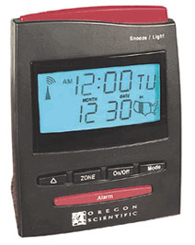

• Network Time Synchronization
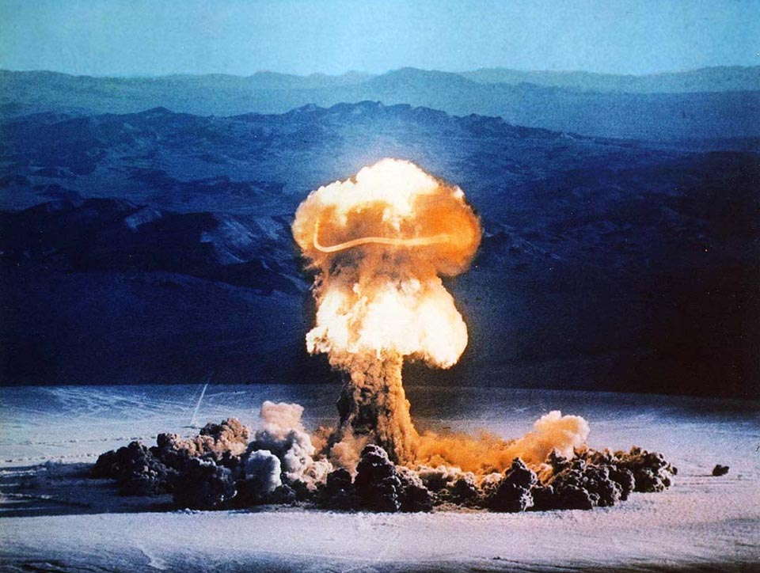
(computer, power, telecommunications, financial)

• Nuclear Safeguards (domestic & international)




rogerj@lanl.gov LAUR-06-2044

Solutions


Though rarely (or never) implemented,

these countermeasures are very effective:

• More sophisticated users & use protocols

• Adversarial Vulnerability Assessments

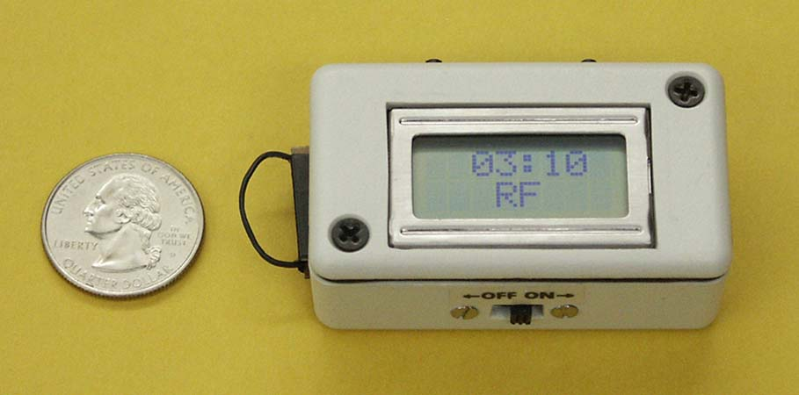
• Novel “Anti-Evidence” Seals & Traps

• Numeric Tokens (to resist drug counterfeiting)
Time Trap

• Better Tamper-Evident Packaging

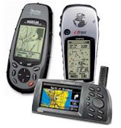
• Computer Physical Security

• Image Algorithm Passwords

• GPS Spoofing Countermeasures

• Innovative approaches to nuclear safeguards

• BH & OPODS Techniques for field data authenticity

• Improving Security Guard Performance using I/O Psychology Tools

